**JOBLINK**

Senior Project

by

**Ahmad Youssef_71630389,**

**Hakam Agha_31730444**

Submitted to the School of Engineering of the

Lebanese International University

Saida, Lebanon

in partial fulfillment of the requirements for the degree of

**BACHELOR OF SCIENCE IN COMMUNICATION ENGINEERING**

**Fall 2023-2024**

**Approved by:**

**Supervisor**

Dr. Hussein Nasrallah

**Committee Member**

Dr. Nour Akkad

**DEDICATION**

This project is dedicated to my beloved parents, the greatest influencers in my life, who.

taught me that everything can be accomplished with hard work, dedication, and self-.

discipline. Thank you for your love, support, and putting me through the best education.

possible. Thank you all for your invaluable contributions to this project. I have special gratitude to my best partner and my close friends, who have been always by my side throughout my senior journey.

Ahmad Youssef

Mainly, I dedicate this project to my parents who had faith in my abilities even in self-doubts. I would also like to thank my university doctors who supervised my educational plan and supported me through my past three years.

Hakam Agha

**ACKNOWLEDGMENT**

I am deeply grateful to all those who contributed to the successful completion of this project on job seekers, especially my group mate Hakam agha. This endeavor would not have been possible without the support, insights, and guidance of several key individuals and organizations.

First and foremost, I would like to extend my sincere thanks to doctor Hussein Nasrallah, who expertise and encouragement were invaluable throughout this project. Their feedback and advice helped shape the direction of the research and ensured its relevance and depth.

Our gratitude extends to everyone who offered their assistance, whether through guidance, encouragement, or technical expertise. Your contributions have played a significant role in the successful completion of this project, and we are deeply thankful for your support.

Lastly, we would like to express our appreciation to our families, friends, and loved ones for their unwavering belief in our abilities and their constant support throughout this journey. Your encouragement and understanding have been our pillars of strength.

**ABSTRACT**

This senior project is a web application designed for a job-seeking platform called JobLink, aimed at streamlining the job search process for both job seekers and employers. From the user’s perspective, a job seeker can create a profile, browse job listings, apply for positions, and track their application status, all from the convenience of their home. Employers, on the other hand, can post job openings, review applications, and communicate with potential candidates through the platform. Additionally, JobLink features tools for career development, including resume-building resources and interview preparation tips. The platform also allows administrators to oversee and manage job listings, user interactions, and the overall functionality of the site. This report will outline the significance of the JobLink application, present diagrams illustrating the system's functionality, detail the design and implementation, and discuss potential future enhancements to further improve the platform.

**TABLE OF CONTENTS**

CHAPTER 1 INTRODUCTION 1

1.1 Background 1

1.2 Problem Statement 2

1.3 General overview of the project 2

1.4 Thesis Outline 3

CHAPTER 2 Survey of Existing Methods and Similar Systems 6

2.1 Introduction 6

2.2 System 1: LinkedIn [1] 6

2.3 System 2: Glassdoor [2] 8

2.4 System 3: Indeed [3] 10

2.5 Systems Comparison 12

2.6 Conclusion and Motivation 15

CHAPTER 3 System Design 18

3.1 Introduction 18

3.2 Requirements and Specification Analysis 18

3.2.1 Functional Requirements 18

3.2.2 Use Case Diagrams 19

3.3 System Architecture 28

3.4 Class Diagrams 32

3.5 Sequence Diagrams 33

3.6 Activity Diagrams 36

3.7 Entity-Relationship (ER) Diagrams 38

3.8 Non-Technical Aspects 39

3.8.1 Financial Viability 39

3.8.2 Stakeholders 42

3.8.3 Scope 43

3.8.4 Risks 47

3.8.5 Schedule and Milestones 48

3.8.6 Ethical and Social Considerations 48

3.8.7 Environmental and Sustainability Considerations 51

3.8.8 Relevant Standards 53

3.9 Conclusion 55

CHAPTER 4 Implementation/Simulation and Testing 56

4.1 Introduction 56

4.2 Implementation Tools 56

4.3 Implementation Summary 57

4.4 Test Cases and Acceptance Criteria 76

4.5 Conclusion 86

CHAPTER 5 Conclusion and Future Work 88

5.1 Conclusion 88

5.2 Future Work 89

**LIST OF FIGURES**

Figure ‎2.1: LinkedIn Cover Page 6

Figure ‎2.2: Real User 7

Figure ‎2.3 Glassdoor Cover Page 8

Figure ‎2.4 Indeed Cover Page 10

Figure ‎2.5 The Indeed Employer Dashboard 11

Figure ‎3.1: User use case diagram 19

Figure ‎3.2: Admin use case diagram 21

Figure ‎3.3: Employer use case diagram 23

Figure ‎3.4: Employee use case diagram 25

Figure ‎3.5: MVC architecture 29

Figure ‎3.6: JOBLINK system architecture 30

Figure ‎3.7: System Class Diagram 31

Figure ‎3.8: User sequence Diagram 32

Figure ‎3.9: Admin Sequence Diagram 32

Figure ‎3.10: Employer Sequence Diagram 33

Figure ‎3.11: Employee Sequence Diagram 33

Figure ‎3.12 Activity Diagram Of Admin 34

Figure ‎3.13: Activity Diagram Of Employer 35

Figure ‎3.14: Activity Diagram Of Employee 36

Figure ‎3.15: Entity-Relationship (ER) Diagram 37

Figure ‎3.16: Cost Benefit Analysis 39

Figure ‎4.1: Home Page 56

Figure ‎4.2: Admin Home Page 57

Figure ‎4.3: Job List Page 58

Figure ‎4.4: Employers Page 59

Figure ‎4.5: Contact Us Page 59

Figure ‎4.6: Employee Registration Page 60

Figure ‎4.7: Employer Registration Page 61

Figure ‎4.8: Successfully Registered 61

Figure ‎4.9: Login Page 62

Figure ‎4.10: Employee Profile Page 63

Figure ‎4.11: Apply Job Page 1 64

Figure ‎4.12: Apply Job Page 2 64

Figure ‎4.13: Applied Job Page 65

Figure ‎4.14: Employer Profile Page 66

Figure ‎4.15: Job Post Page 67

Figure ‎4.16: Posted Job Post Page 67

Figure ‎4.17: Job Applicant Page 68

Figure ‎4.18: Employee Details Page 69

Figure ‎4.19: Change/Recover Password Page As Employer 70

Figure ‎4.20: Find Employee Page 71

Figure ‎4.21: Admin Charts 71

Figure ‎4.22: Arabic Language 72

Figure ‎4.23: French Language 72

Figure ‎4.24: English Language (Original) 73

Figure ‎4.25: Ai Translation At Right Top 73

Figure ‎4.26: Wrong Credentials 75

Figure ‎4.27: Logging In With Admin Approval Message 75

Figure ‎4.28: Editing Employee Profile 77

Figure ‎4.29: Editing Employer Profile 78

Figure ‎4.30: Employee registration 79

Figure ‎4.31: Employer Registration 80

Figure ‎4.32: Job Post Page 1 81

Figure ‎4.33: Job Post Page 2 82

Figure ‎4.34: Missing message part 83

Figure ‎4.35: Missing name or email part 83

**LIST OF TABLES**

Table 1: Comparison Table Based on Graphical Interfaces 13

Table 2: Comparison Table Based on Content and Functionality 14

Table 3: Comparison Table Based on Features 14

Table 4: Scheduling Tasks and Milestones 45

**LIST OF SYMBOLS**

* ADA: **Americans with Disabilities Act.**
* CBA: Cost Benefit Analysis.
* **CCPA: California Consumer Privacy Act.**
* CSR: **Corporate Social Responsibility.**
* CSS: Cascading Style Sheet.
* **EEO: Equal Employment Opportunity.**
* GDPR: **General Data Protection Regulation.**
* GUI: Graphical User Interface.
* HTML: Hyper Text Markup Language.
* IP: Internet Protocol.
* ISO: International Organization for Standard.
* MVC: Model-Viewer Controller.
* SHRM: **Society for Human Resource Management.**
* UI: User Interface.
* UML: Unified Modeling Language.
* WCAG: **Web Content Accessibility Guidelines.**

# INTRODUCTION

## Background

Throughout history, humans have sought opportunities to meet their needs for food and economic resources, often exchanging effort, services, or work for wages. As societies developed and populations grew, the demand for goods increased, necessitating heightened production and, consequently, more labor. This has led to two prominent trends: first, the difficulty in finding decent work in developing countries due to increasing consumption and dwindling employment opportunities; and second, a significant boom in job creation within factories, laboratories, and production-focused companies in developed countries, resulting in a rise in job advertisements.

The growing demand for employment has facilitated the emergence of many recruitment agencies, which play a crucial role in connecting employers with job seekers. These agencies collect and systematize data from both sides, effectively streamlining the recruitment process and benefiting both parties. By acting as intermediaries, they help to match skills with job opportunities more efficiently.

Advancements in technology, particularly the Internet, have revolutionized recruitment by enabling the creation of online job platforms. These platforms have expanded the search scope, making the recruitment process more efficient, transparent, and user-friendly. The integration of artificial intelligence has further enhanced these platforms, rendering them modern, fast, convenient, and highly effective in meeting the needs of both job seekers and employers.

## Problem Statement

Whether considering the increased demand for labor in developed countries or unemployment in developing countries, both scenarios involve difficulties in matching individuals with appropriate jobs or companies suited to their skills and experience. How to look for a job? Where should they submit their application, and whom should they consult? What should the application include? These are all challenges that hinder the job application process. Similarly, companies face significant obstacles, such as locating the necessary expertise and competencies quickly and cost-effectively. A smart search engine could address these issues by facilitating continuous communication between employers and job seekers. It can also assist applicants in completing a clear form to find suitable job opportunities more efficiently

## General overview of the project

Project is an online recruitment system designed to provide a positive experience for job seekers who are looking for well-paying, reliable, and comfortable employment. The system also assists job seekers by providing a clear and concise form that employers can easily read, eliminating unnecessary details that might hinder the recruitment process. Additionally, it offers subscribers the ability to send and receive written messages with employers, stay informed about major companies, and follow up on job details.

For companies seeking a strong workforce and qualified employees, the site gathers and displays data from job applicants, ensuring that it is continuously and automatically updated. This enables employers to schedule interviews, to which job seekers can respond or denied. The platform efficiently collects and stores data from all users (job seekers, employers, and administrators), allowing it to be modified at any time. It is a user-friendly and transparent platform suitable for research and communication.

From a programming perspective, this project includes several implementation plans, such as maps and graphs, to ensure complete clarity for both supervisors and users. It features UML diagrams, use cases, activity diagrams, entity-relationship diagrams, and financial viability analysis, ensuring ease of reading and understanding.

In addition to what was mentioned, we have provided the program with the ability to collect data and communicate via artificial intelligence, to facilitate search and improve quality of applications, automate manual tasks, reduce time, automate messaging services and provide better experience with less human interaction.

## Thesis Outline

The first chapter of this report presents the main idea of the project by exposing the importance of the online recruitment platform and what problems can it solve and how it can be the right place that can handle these problems and organize the goals of the job seekers and companies at the same time.

Then, Chapter 2 examines the currently available systems utilized by similar companies, providing a detailed comparison of their respective advantages and disadvantages. This analysis includes an evaluation of features, usability, and performance, highlighting where each system excels and where they fall short. Based on these insights, the chapter concludes by making a case for the development of a new online platform. This proposed platform aims to address the shortcomings identified in the existing systems, offering enhanced functionality and user experience to better meet the needs of both job seekers and employers.

Chapter 3 delves into the functionality of the system design by thoroughly presenting various diagrams, including use case diagrams that outline the system's interactions, class diagrams that define the system's structure, sequence diagrams that illustrate the flow of operations, activity diagrams that show the workflow, and entity-relationship diagrams that depict the data model. These diagrams collectively provide a comprehensive view of how the system operates. Additionally, the chapter covers the technical requirements necessary for the system's implementation and offers an in-depth analysis of these elements. Following this detailed illustration, the chapter concludes by drawing significant insights and conclusions about the system's design and functionality.

Chapter 4 provides a detailed overview of the tools and technologies used during the implementation of the First-Opportunity recruitment platform. It showcases various screenshots of the platform, illustrating key features and interfaces. These visuals help the reader gain a clear understanding of the system’s development process, including the front-end design, back-end functionality, and integration of various components. The chapter also explains how these tools were utilized to build and refine the platform, ensuring it meets the intended design and user requirements.

Finally, Chapter 5 analyzes the project lifecycle detailed in this report and assesses its benefits for First-Opportunity users. It also outlines potential future enhancements that could be implemented to further improve the features of the web application.

# Survey of Existing Methods and Similar Systems

## Introduction

Job-Seeking websites act as crucial intermediaries in the labor market, influencing job search behaviors, matching efficiency, and the overall dynamics of unemployment rates on a global scale. Their impact extends beyond individual job placements to encompass broader economic indicators and policy considerations. These platforms use algorithms and filters to match candidates with job postings that closely align with their skills and experience. This efficiency can reduce the time it takes for individuals to find employment, thereby lowering the unemployment rate more quickly.

Based on the above, we will discuss three systems that have made significant investments in this field and have become major international players. Our focus lies on Indeed, LinkedIn, and Glassdoo.

## System 1: LinkedIn [1]

LinkedIn was launched on May 5, 2003, and it was a business and employment-focused social media platform that works through websites and mobile apps, refer to Figure ‎2.1. LinkedIn allows members (both workers and employers) to create profiles and connect in an online social network which may represent real-world professional relationships. Your LinkedIn profile acts as an online resume and portfolio. It's crucial to keep it updated with your latest skills, experiences, and accomplishments. Also, the job search tool allows you to filter job listings based on various criteria, such as location, industry, company size, and experience level. One of LinkedIn’s strengths is its networking capabilities, connecting with professionals in your industry, joining relevant groups, and engaging in discussions can help you build valuable relationships and uncover job opportunities through referrals and recommendations, refer to Figure ‎2.2. LinkedIn allows you to research companies by looking at their profiles, which can include information on company culture, recent updates, and job openings. More than that, you can list your skills and receive endorsements from colleagues and peers. This can enhance your credibility and make your profile stand out to recruiters. Overall, LinkedIn is a powerful tool for job seekers, combining job listings, networking opportunities, and professional development into one platform.

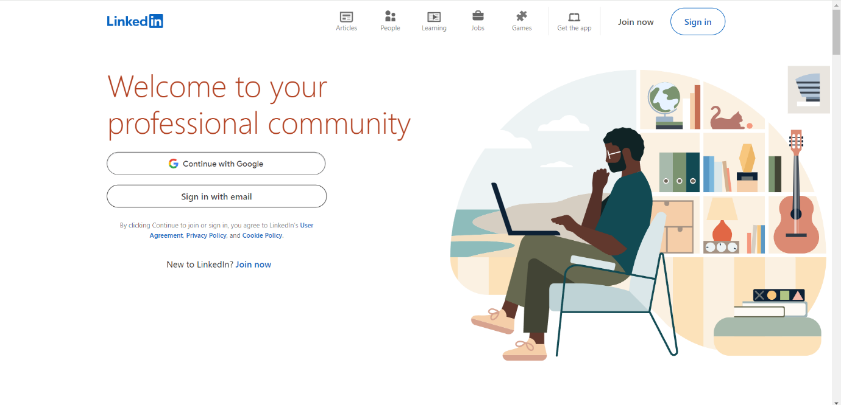

Figure ‎2.1: LinkedIn Cover Page

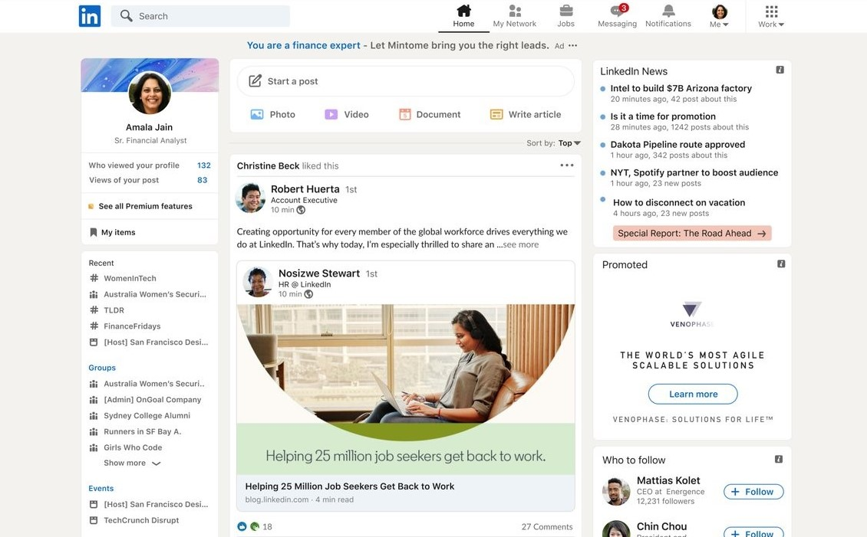

Figure ‎2.2: Real User

## System 2: Glassdoor [2]

Glassdoor is a comprehensive job-seeking platform that seamlessly integrates job listings, company reviews, salary data, and interview insights to assist users in making informed career decisions, as shown in Figure ‎2.3. Technically, the website offers a robust job search engine with advanced filtering options, allowing users to customize searches by job title, location, company, and salary range. It also provides detailed company profiles, including aggregated employee reviews, company ratings, and specific salary information, which are crucial for evaluating potential employers. Users can set up personalized job alerts to receive notifications about new job postings that match their criteria and access insights into interview processes shared by other candidates. The mobile app extends these functionalities, providing on-the-go access to job searches and company reviews. From a user perspective, Glassdoor’s interface is designed for ease of navigation, with a clean layout that simplifies browsing through job listings and company information. The platform’s user-generated content, such as reviews and interview experiences, adds a layer of transparency, enabling users to get an authentic glimpse into company cultures and compensation practices. This combination of detailed, user-contributed information and intuitive design makes Glassdoor a valuable tool for job seekers looking to navigate their career paths effectively.

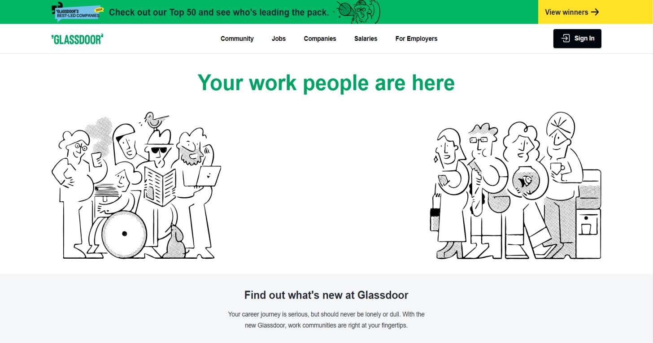

Figure . Glassdoor Cover Page

## System 3: Indeed [3]

Indeed, is a widely-used job search platform known for its extensive job listing database and user-friendly features that support job seekers in their career pursuits, refer to Figure ‎2.4 Technically, Indeed operates as a powerful job search engine that aggregates listings from various sources, including company websites and job boards. It offers advanced search functionalities, allowing users to filter jobs by title, location, company, salary range, and experience level. Users can create tailored job alerts to receive notifications about new opportunities matching their criteria and access a comprehensive company directory with company reviews and salary insights. Indeed's resume builder and application tracking tools simplify the job application process, while the mobile app ensures that users can search for jobs and manage applications from anywhere. From a user perspective, Indeed is praised for its straightforward, intuitive interface, which facilitates easy navigation through job listings and application submissions, as shown in Figure ‎2.5. The site’s design is focused on minimizing friction in the job search process, with clear call-to-action buttons, a simple application process, and features like “Apply Now” and “Save Job” enhancing usability. Indeed user-centric approach, combined with its vast repository of job listings and helpful resources, makes it a practical and accessible tool for job seekers aiming to find their next opportunity efficiently.

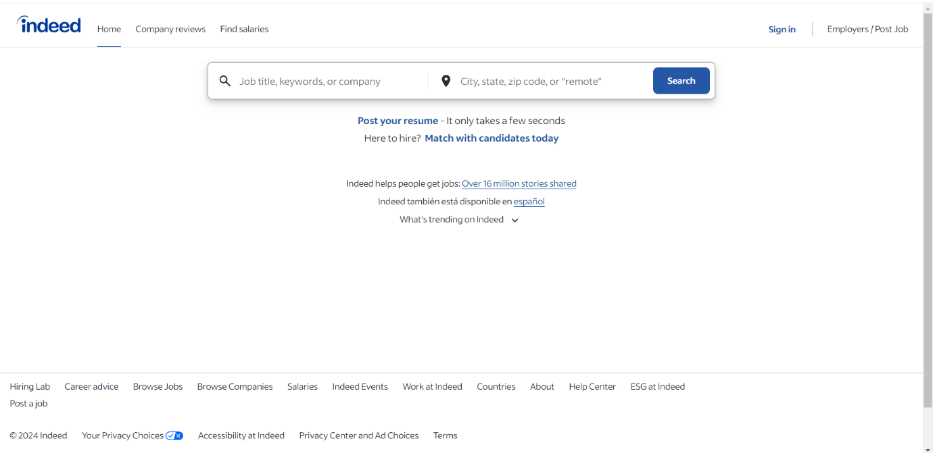

Figure ‎2.4 Indeed Cover Page

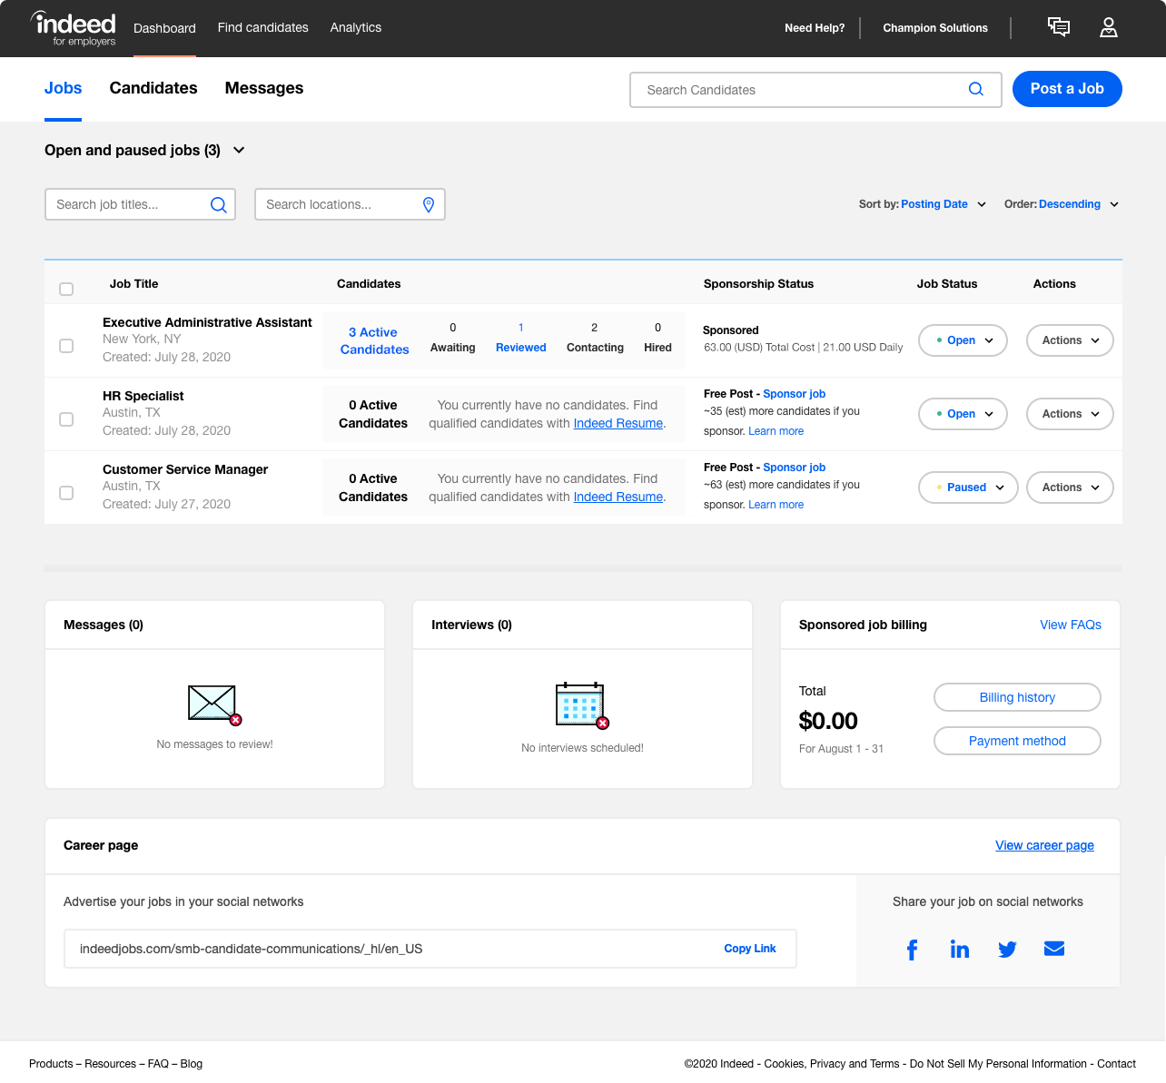

Figure ‎2.5 The Indeed Employer Dashboard

## Systems Comparison

LinkedIn, Glassdoor, and Indeed each website has its user interface, navigation, design, and responsiveness, each platform has its unique strengths, as shown in Table 1. LinkedIn boasts a sophisticated, professional interface designed for networking and career development. While it offers a rich array of features, its complex layout can occasionally make navigation less intuitive. However, its design is responsive, ensuring a seamless experience across various devices. Glassdoor provides a clean, user-friendly interface that focuses on job searches and company insights. Its straightforward design facilitates easy navigation between job listings, reviews, and salary information, and it is highly responsive, maintaining a smooth experience on both desktop and mobile. Indeed features a minimalist design that prioritizes simplicity and efficiency, making job searches and applications straightforward and quick. Its interface is highly responsive, ensuring that users have a consistent and effective experience across all devices. In summary, LinkedIn excels in professionalism and feature richness, Glassdoor in clarity and user-friendliness, and Indeed website in simplicity and ease of use.

These three websites each approach content structure and usability differently, reflecting their distinct purposes, refer to Table 2. LinkedIn provides a rich content structure with a professional networking focus, featuring well-organized profiles, industry updates, and thought leadership articles. Its usability is bolstered by a sophisticated content management system that enables seamless navigation through connections, job postings, and personal achievements. Glassdoor offers a more specialized content structure centered around company reviews and salary data, with user-generated content playing a central role. While its usability is strong for job seekers looking for company insights, the site can be less intuitive due to its focus on review aggregation. Indeed, stands out with its extensive job listing database and straightforward content structure designed for efficient job searching. Its content management system supports dynamic, real-time job postings and user reviews, though the overall usability might be less polished compared to LinkedIn's network-oriented features. Each site effectively leverages its content management system to deliver relevant information, with LinkedIn excelling in professional networking, Glassdoor in company insights, and Indeed in job search functionality.

When comparing LinkedIn, Glassdoor, and Indeed, notable differences emerge in their security measures, third-party integrations, accessible content, and registration processes, as shown in Table 3. LinkedIn prioritizes security with robust measures such as two-factor authentication and advanced encryption to protect user data, and it integrates seamlessly with various third-party tools like Salesforce and Microsoft Office, enhancing its utility for professionals. Glassdoor also employs strong security protocols but is more focused on user privacy regarding company reviews and salary information. Its third-party integrations are less extensive, mainly connecting with job application tools. Accessibility is well-handled across all platforms, with LinkedIn and Indeed offering broad content access regardless of location, while Glassdoor provides localized reviews based on user input. In terms of registration, LinkedIn's form is detailed, asking for professional information to tailor networking opportunities, whereas Glassdoor and Indeed feature simpler forms primarily requiring basic contact and job-related details. Each site addresses security and integration based on its core functionalities, reflecting their different priorities and user needs.

Table 1: Comparison Table Based on Graphical Interfaces

|  |  |  |  |
| --- | --- | --- | --- |
| **Criterion 1** | **LinkedIn** | **Glassdoor** | **Indeed** |
| **Graphical Interface** |
| Good user interface | ✓ | ✓ | ✓ |
| Easy and effective navigation | ✓ | ✓ | X |
| Simple and professional Design | ✓ | ✓ | ✓ |
| Responsive | ✓ | ✓ | ✓ |

Table 2: Comparison Table Based on Content and Functionality

|  |  |  |  |
| --- | --- | --- | --- |
| **Criterion 2** | **LinkedIn** | **Glassdoor** | **Indeed** |
| **Content and Functionality** |
| Quality content structure | ✓ | X | ✓ |
| Usability | ✓ | ✓ | ✓ |
| Dynamic content | ✓ | X | X |
| Content management system | ✓ | ✓ | ✓ |

Table 3: Comparison Table Based on Features

|  |  |  |  |
| --- | --- | --- | --- |
| **Criterion 3** | **LinkedIn** | **Glassdoor** | **Indeed** |
| **Features** |
| Security measures | ✓ | X | ✓ |
| Third party integration | ✓ | X | X |
| Accessible content and location | ✓ | ✓ | ✓ |
| Registration form | ✓ | ✓ | ✓ |

## Conclusion and Motivation

We have compared multiple systems and identified several significant differences. Based on our previous discussions, the following points highlight these distinctions:

1. **Simplifying complex research tools** to make them smoother and more user-friendly.
2. **Facilitating social networking** by enabling users to find friends and colleagues.
3. **Generating revenue** across various product lines.
4. **Offering services free of charge** to users.
5. **Building trust and admiration** among users.
6. **Filtering out repetitive ads and listings** to improve the user experience.

In this project, we will address and enhance these critical aspects to develop an upgraded recruitment platform. The new platform will be designed to offer greater clarity in its interface, ensuring that users can navigate and utilize its features with ease. It will also focus on improving reliability by incorporating robust security measures and stable performance. Additionally, the platform will be optimized for user-friendliness, providing an intuitive experience for both job seekers and employers. Finally, an advanced search engine will be integrated, allowing users to efficiently find and match with the most relevant job opportunities or candidates.

# System Design

## Introduction

In this chapter, we will introduce a detailed representation of the project requirements and its functionality. Also, the structures of use case diagrams that describe the high-level functions and scope of a system. Moreover, a UML is used in system design to visualize the following structures: class diagram, state diagram, sequence diagram, and entity-relationship diagram.

## Requirements and Specification Analysis

In this section, we will explain the requirements of the project and use cases that are important to provide the best illustration for website structure which improves user experience and allows more specified features that distinguish it from other similar systems.

### Functional Requirements

Here we will describe and list the functionality of the whole system and make it clear for users to understand and achieve their tasks. Procedures that encourage employers and consumers alike to use the system in a safe, easy, and simple way, these important procedures are:

* The user can register to view the content and interact with the content. Employers can also register and watch the content, and the administration can follow the interactions of registered users.
* Users and employers can edit or delete the file and create a file with new content
* Users can view a large number of jobs through the search process in advanced, clear, and easy ways
* Users can view a large number of jobs through the search process in advanced, clear, and easy ways
* Employers can open new job files and enter and modify information about open jobs
* Users can create their CV files, and employers can follow up on these files
* The system provides an easy and uncomplicated search process with the help of artificial intelligence software, which makes it advanced

### Use Case Diagrams

A simple diagram that demonstrates the basic flow of the system. We will be illustrating use case diagrams for the following actors: Registered Users, Admins, Registered Employers, and Guests. According to these use case diagrams we will also demonstrate the actions each of those actors can take in Figure ‎3.1, Figure ‎3.2, Figure ‎3.3 and Figure ‎3.4.

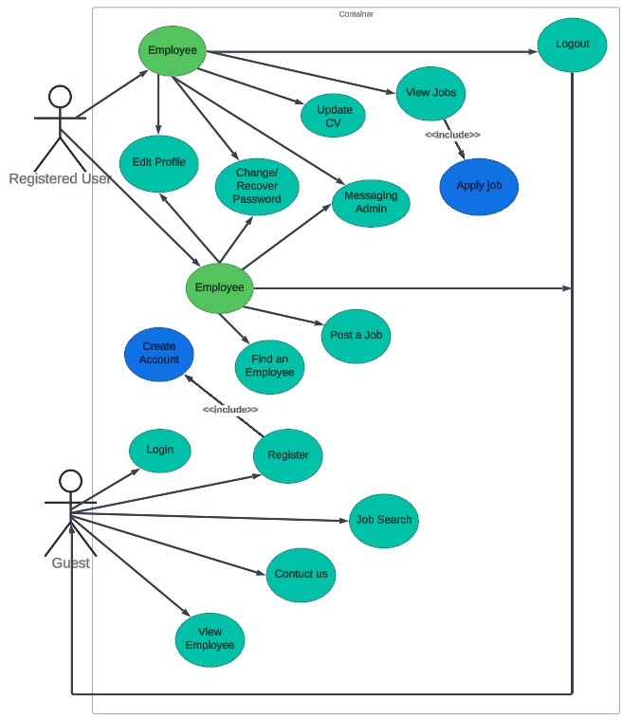

Figure ‎3.1: User use case diagram

|  |  |
| --- | --- |
| **Use Case ID** | 01 |
| **Use Case Name** | Website mechanism |
| **Primary Actor** | Registered User |
| **Secondary Actor** | Guest |
| **Purpose** | For the guest to create a new account as an employee or employer and login to use the website according to his condition. |
| **Condition** | Guest should have an account with a valid username and password, and choose his domain. |
| **Event and Steps** | **Step 1:** Guest needs to register to create an account, then he can login.  **Step 2:** Guest can contact admin by contact us message, view employee, and can search for a job.  **Step 3:** After creating an account, if a user is an employee or employer, he can edit his profile.  **Step 4:** If the user is an employee, he should upload his CV.   * If he is an employer he should post a job. |
| **Exception** | Invalid email or password |
| **Conclusion** | The system is less complicated for the guest to log in to the website. |

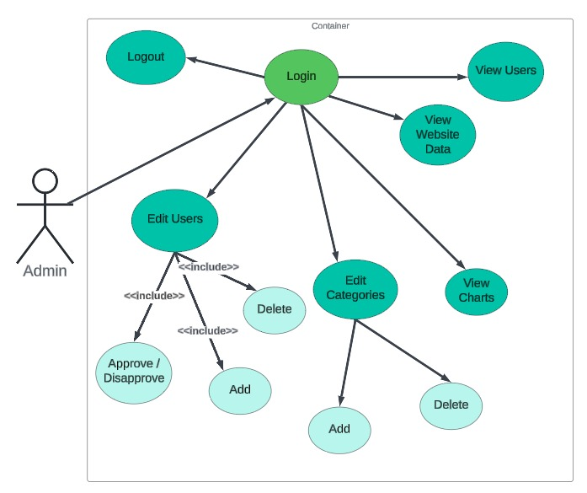

Figure ‎3.2: Admin use case diagram

|  |  |
| --- | --- |
| **Use Case ID** | 02 |
| **Use Case Name** | Managing and Monitoring Organization |
| **Primary Actor** | Admin |
| **Secondary Actor** | None |
| **Purpose** | Admin can approve and disapprove the created account and can delete or add a new user employee and employer |
| **Condition** | Access privileges |
| **Event and Steps** | **Step 1:** Admin logs in to the website by entering username and password.  **Step 2:** Admin views his internet offers where he can add, approve/disapprove, or delete a user.  **Step 3:** Admin views the registered users and can approve or disapprove the account.  **Step 4:** Admin can view all website data and view users data and posted advertisement  **Step 5:** Admin can edit categories by adding or deleting  **Step 6:** Admin can view charts that represent the visitor's numbers weekly or monthly |
| **Exception** | Invalid email or password |
| **Conclusion** | The system is less complicated for the user either employee or employer to log in to the website. |

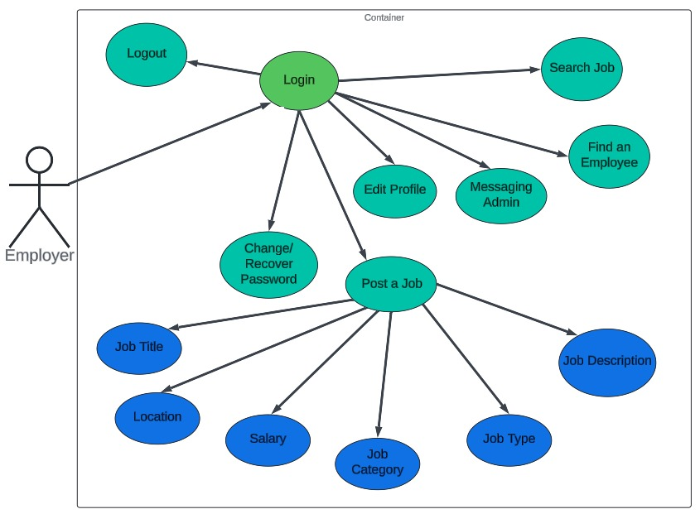

Figure ‎3.3: Employer use case diagram

|  |  |
| --- | --- |
| **Use Case ID** | 03 |
| **Use Case Name** | Posting a job |
| **Primary Actor** | Employer |
| **Secondary Actor** | None |
| **Purpose** | * Allow the employer to manage his profile. * Allow the employer to post a job and find an employee. * Allow the employee to see the job list and apply for posted jobs. |
| **Pre-conditions** | * Registration * A valid email and password |
| **Event and Steps** | **Step 1:** Login into the System.  **Step 2:** The employer can edit his profile so that the employee gets the required information.  **Step 3:** Employer can post a job with details like job description, job type, salary, location…  **Step 4:** Also can change/recover password.  **Step 5:** Can message the admin.  **Step 6:** Can find an employee.  **Step 7:** And more he can update the cv and can go to search job page. |
| **Exception** | Invalid email or password. |
| **Conclusion** | Employers will easily insert the business information, the job title, and the open position. The aim here is to make communication easy and clear between employer and employee which makes the use of the platform comfortable. |

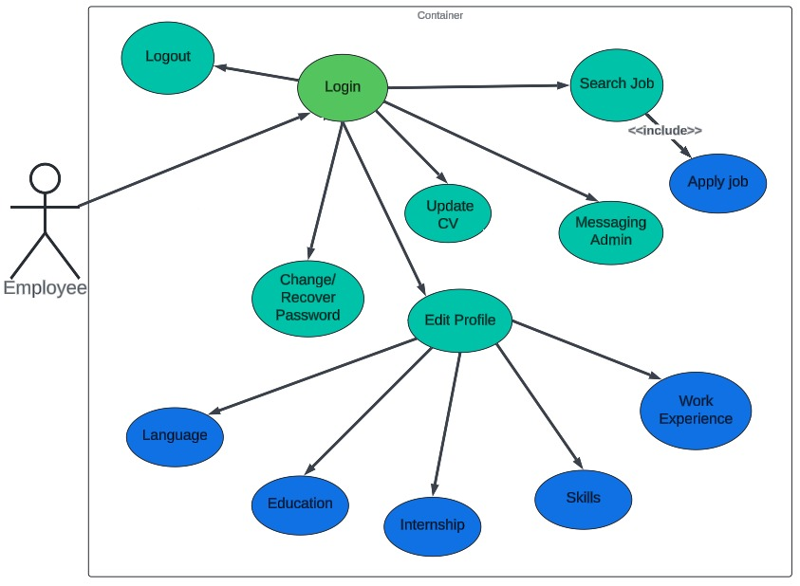

Figure ‎3.4: Employee use case diagram

|  |  |
| --- | --- |
| **Use Case ID** | 04 |
| **Use Case Name** | Search for a job. |
| **Primary Actor** | Employee. |
| **Secondary Actor** | None. |
| **Purpose** | * To allow the employee to manage his profile. * To allow the employee to update his CV to find a job. * To allow the employee to see the job list and apply for a posted job. * To help the employer to find a qualified employee according to his CV. |
| **Pre-Condition** | * Registration. * A valid email and password. |
| **Event and Steps** | **Step 1:** Login into the System.  **Step 2:** The employee can edit his CV so that he gives clear information about himself.  **Step 3:** Employee can update his profile such that internship, work experience, skills, education…  **Step 4:** Employee can change/recover password.  **Step 5:** Also he can message the admin.  **Step 6:** Can also search for a job by filtering like category, salary, type, and location, and can apply any job he want. |
| **Exception** | Invalid email and password |
| **Conclusion** | With this use case, the employee will easily insert the information related to him, and display his CV to make the communication easy and more professional between employee and employer. |

## System Architecture

The recruitment platform's system architecture features a three-tier design with two front-end layers: one dedicated to the user interface and the other for the admin-side business logic and data processing. Additionally, there is a database layer responsible for data storage and management.

Here is a breakdown of each layer:

* Front-end layer (Admin/Client side): This layer will be responsible for handling the graphical user interface (GUI) and user admin functionality. It will include both a client-side and an admin-side component. The client-side component will be used by individuals and companies to search for open positions and post job titles. The admin-side component will be used by the platform administrator to monitor server activity and administer logging, backup processes, add users and manage their access. The client-side section enables the platform users to explore various activities and services, as well as interact with forms and buttons to input and request data. The app is accessible through smart devices and automatically adjusts to fit different screen sizes. Users can submit inputs and make requests, which are transmitted to the server for backend processing.
* The backend (Server-side): this layer will handle the business logic and data processing for the website. It includes a web server that interacts with the front-end layer, a file server for data storage, and a database server for storing user information. During the development of the JOBLINK platform, the MVC (Model-View-Controller) pattern was implemented. This pattern divides the application into three main components: models, UI (user interface), and adapters. The models manage the application's data and business logic, handling tasks such as data retrieval, storage, and manipulation. The UI component is responsible for displaying information to users and capturing their input, consisting of various visual elements like screens, forms, and buttons. Adapters serve as intermediaries between the models and the UI, facilitating smooth data communication between these two components. They convert data from the models into a format suitable for display in the UI and vice versa. Utilizing the MVC pattern ensured a structured, organized, and reusable development process for JOBLINK .

Furthermore, in the Project, all Java classes have been organized into distinct packages to enhance structure and maintainability. Some of the packages used include:

* Enumerations Package: This package contains classes that define different payment methods. Enumerations are typically used to represent a fixed set of values such as the type of payments (debit, visa card, PayPal, or cash).
* File Upload Package: The classes in this package handle image uploading functionality. They provide methods and utilities to manage the uploading process and handle file-related operations.
* Fragments Package: This package contains classes representing various fragments in the application. Fragments are reusable UI components that can be combined to create different screens or sections of the app.
* Interface Fragment Refresh Package: This package includes interfaces related to fragment refreshing. These interfaces define methods that allow fragments to communicate and update their content or perform specific actions.
* Utility Package: The classes in this package provide utility functions and helper methods for configuration settings, retrieving IP addresses, getting image paths, and managing other data-related operations.
* Admin Package: encompasses all functionality and components relevant to the administration of the application. This package contains classes and modules that manage administrative tasks and privileges.

By categorizing classes into distinct packages based on their specific functions, the project's codebase becomes more systematically organized, modular, and easier to navigate. This method ensures that related classes are grouped, making the code more intuitive to work with. It enhances code reusability by allowing developers to easily locate and reuse components across different parts of the project. Furthermore, it improves maintainability by making the codebase more manageable and simplifying the process of tracking and fixing bugs. Scalability is also enhanced, as the structured organization facilitates the addition of new features and functionalities without disrupting existing code as shown in Figure ‎3.5 and Figure ‎3.6.

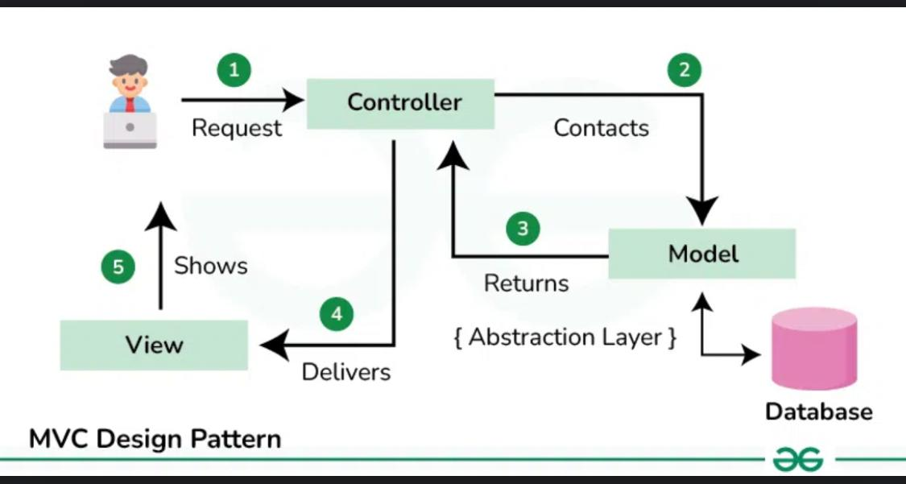

Figure ‎3.5: MVC architecture

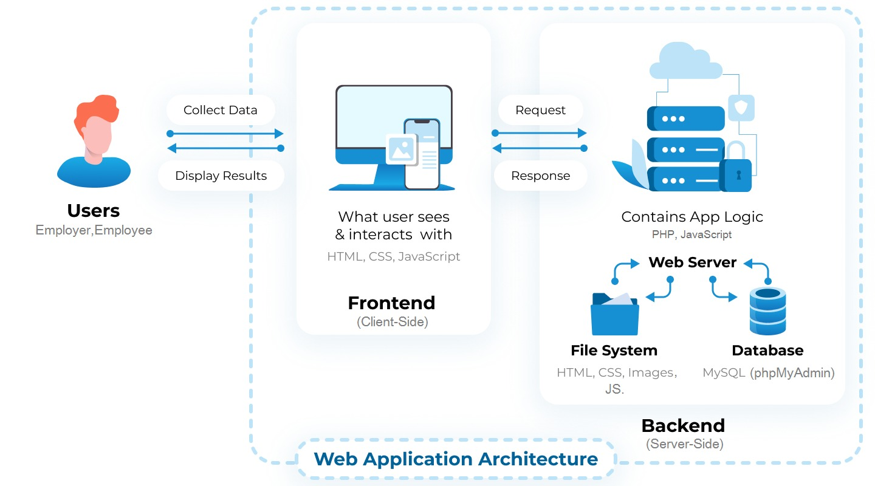

Figure ‎3.6: JOBLINK system architecture

## Class Diagrams

This section presents the UML Class Diagram of the system, which depicts the system's basic hierarchy and the relationships between its entities. The diagram serves as a crucial tool for designing an effective and well-organized system structure, and it is essential to develop it before beginning the project.

Figure illustrates the class diagram, which includes all the system's classes, their attributes, operations, and relationships with other objects. It is worth noting that every model in the system must extend an Active Record to communicate with the database effectively, and the User model must implement the Identity Interface since it provides identity information as shown in Figure ‎3.7.

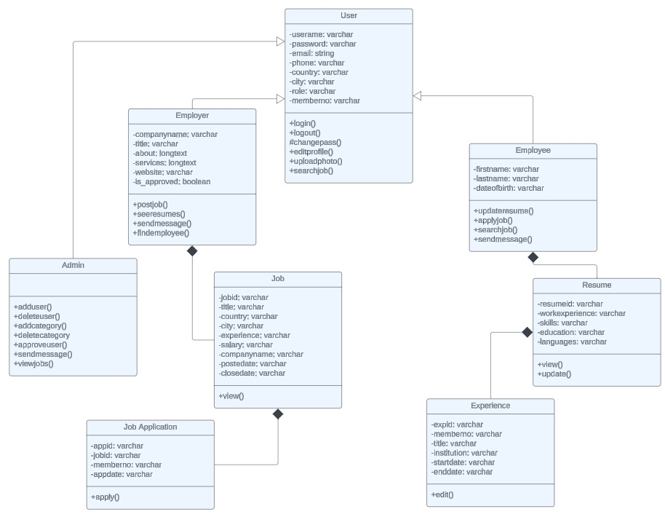

Figure ‎3.7: System Class Diagram

## Sequence Diagrams

A sequence diagram is a key behavioral diagram used at the design level. It portrays the sequence of events, messages, and actions exchanged between actors and objects in a time-ordered manner. This diagram demonstrates how a collection of objects interacts and in what sequence. It is instrumental in documenting and understanding the logical flow within a system, as shown in Figure ‎3.8, Figure ‎3.9, Figure ‎3.10 and Figure ‎3.11.

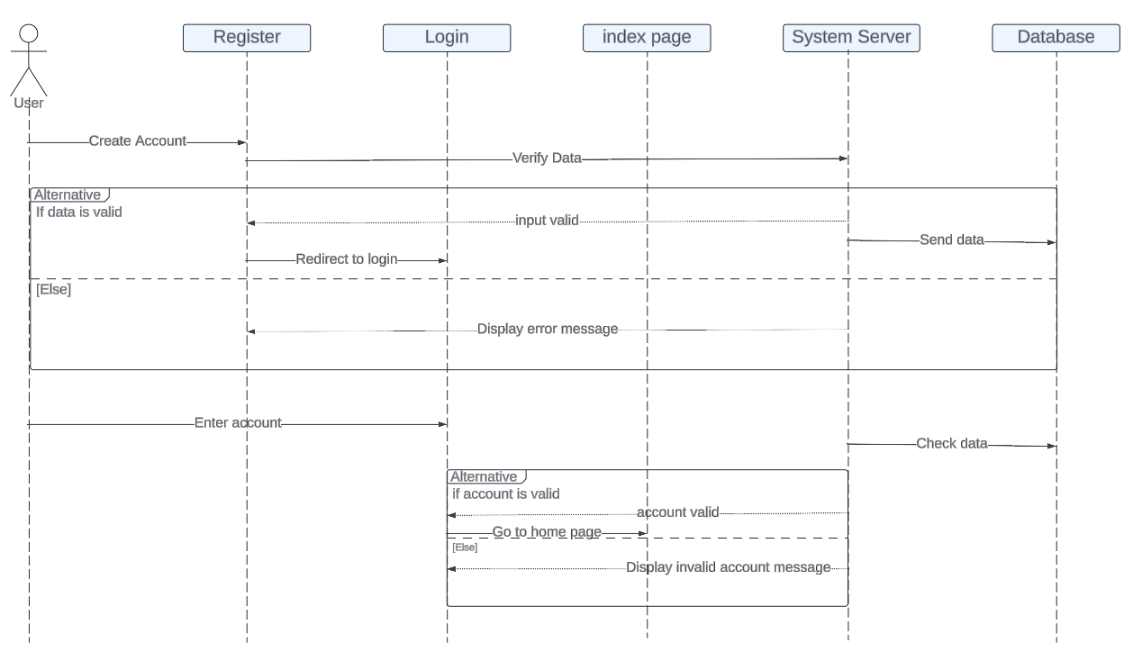

Figure ‎3.8: User sequence Diagram

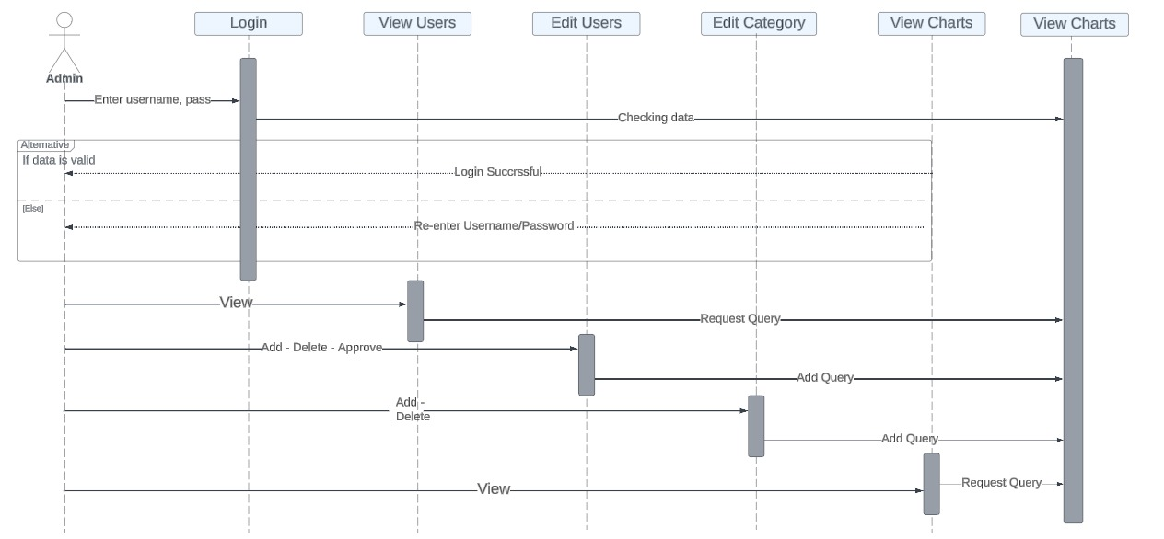

Figure ‎3.9: Admin Sequence Diagram

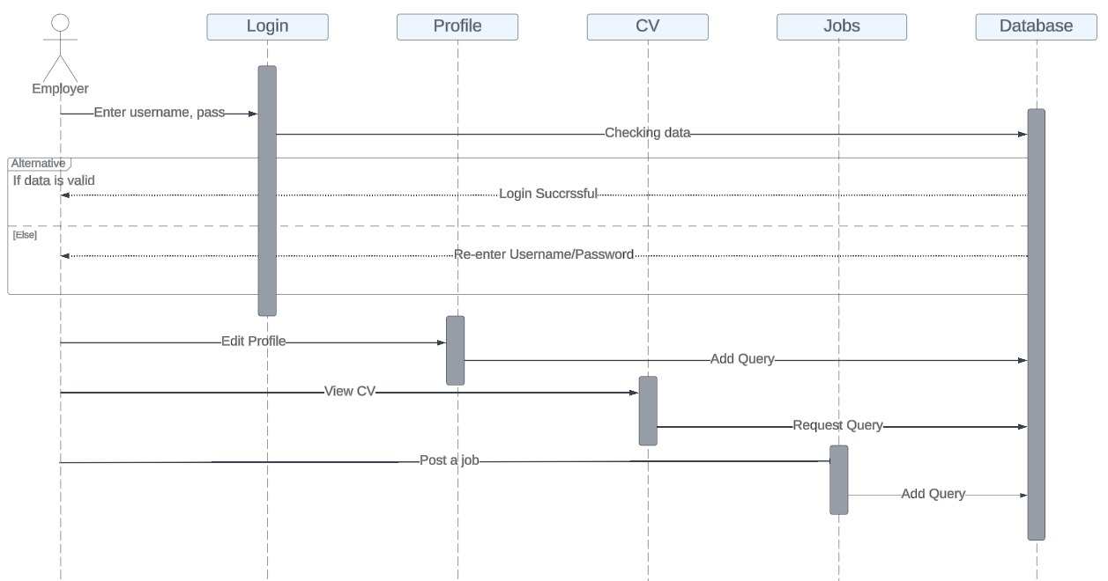

Figure ‎3.10: Employer Sequence Diagram

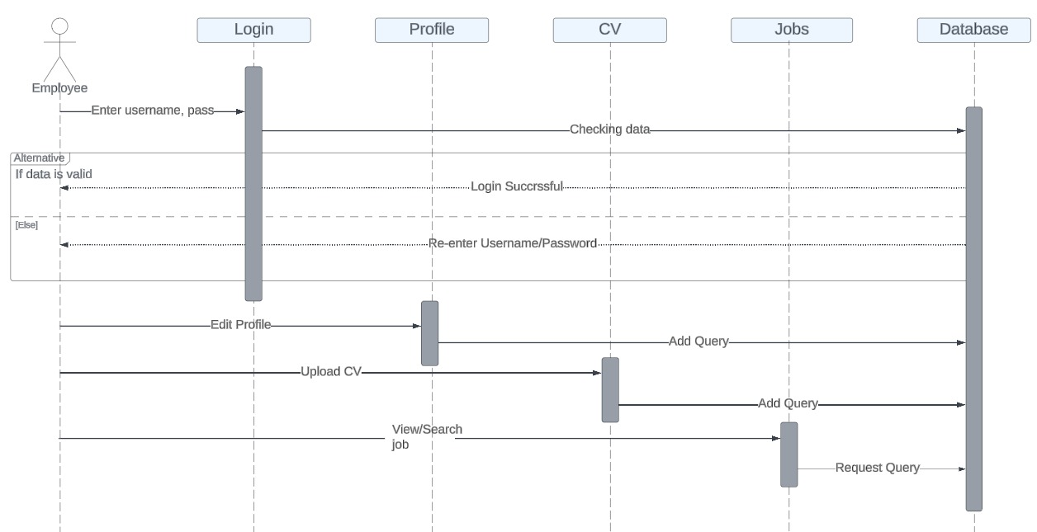

Figure ‎3.11: Employee Sequence Diagram

## Activity Diagrams

This section will present the activity diagrams that form the foundation of this website. Activity diagrams are a visual tool that illustrates how activities are organized to provide a service at different levels of abstraction, particularly helpful when making complex decisions since they provide a clear and organized representation of the process, as shown in Figure ‎3.12, Figure ‎3.13 and Figure ‎3.14.

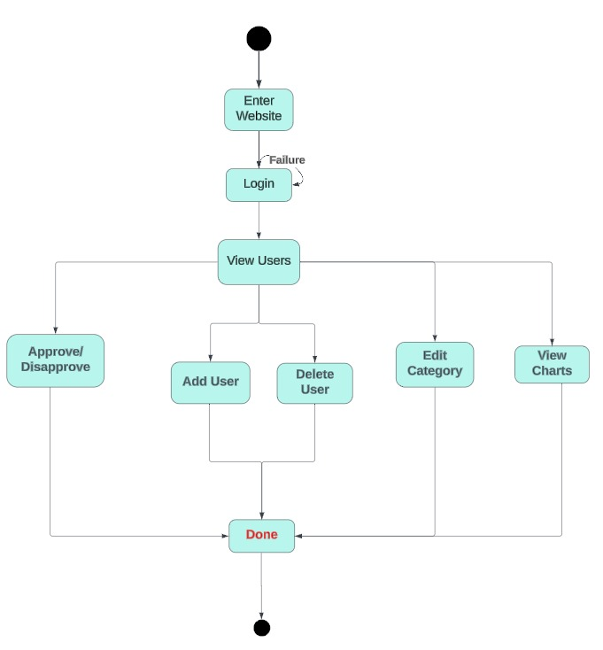

Figure . Activity Diagram Of Admin

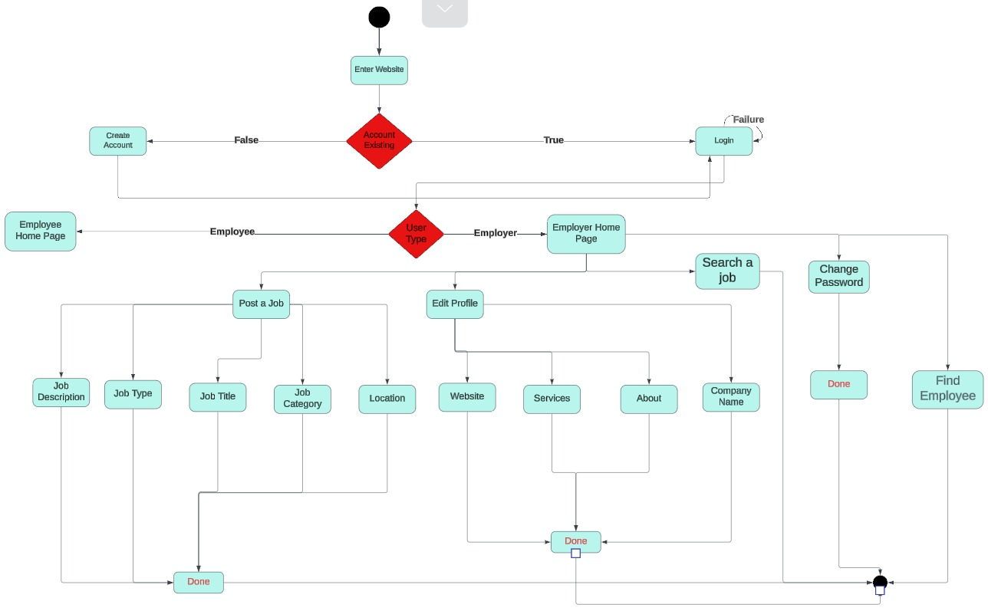

Figure ‎3.13: Activity Diagram Of Employer

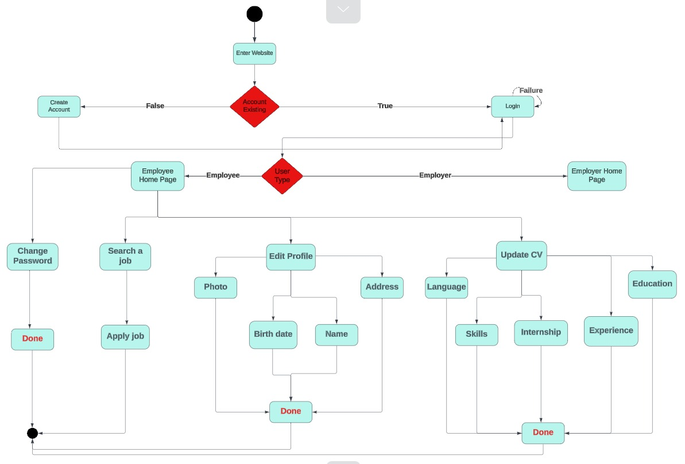

Figure .: Activity Diagram Of Employee

## Entity-Relationship (ER) Diagrams

An Entity-Relationship (ER) diagram is a visual representation of the data and its relationships within a system. It serves as a blueprint for designing databases by outlining entities (objects or concepts), attributes (properties of entities), and the relationships between these entities. ER diagrams are fundamental tools in database modeling, helping to clarify the structure and organization of data, making it easier to implement, manage, and modify the database effectively.

This structure ensures that we capture the relationship between users, job postings, and applications comprehensively, as shown in Figure ‎3.15.

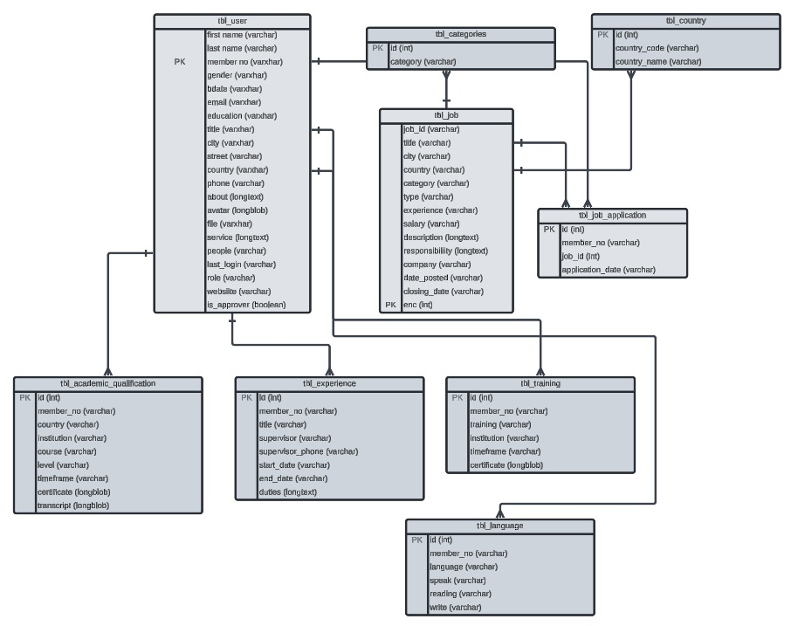

Figure ‎3.15: Entity-Relationship (ER) Diagram

## Non-Technical Aspects

### Financial Viability

In this project Web development involves the technical implementation and functionality of a website. It encompasses the coding and programming required to bring the design to life. Web developers use technologies like **HTML, CSS and JavaScript** to build the user interface, while implementing back-end logic with programming languages like PHP, Python or Ruby.

Financial Viability **CBA** can help you make more informed and rational decisions about hiring by providing a clear, quantifiable framework for evaluating the impact of a new hire on your business, avoiding overestimating or underestimating the costs and benefits, allowing you to compare different scenarios and options and weigh the trade-offs involved, and supporting your decision with evidence and data that can be communicated to others.

**Cost**

Cost is the value of money that is used for investment. There are many types of costs used in cost-benefit analysis.

* **Direct Cost:** It is directly associated with projects like the budget used for manufacturing, raw materials, and inventory.
* **Indirect Cost:** This cost is not directly associated with the system like the cost of electricity, utilities, and rent.
* **Intangible cost:** The cost that cannot be accurately assessed like human resources.
* **Opportunity cost:** It includes alternative investment.

**Benefits**

Benefits are desirable advantages gained from the total investment. Here are some types of benefits;

* **Direct benefit:** This type of benefit is specific and fixed.
* **Indirect benefit:** These benefits are not specific and fixed.
* **Intangible benefits:** These include benefits that are difficult to measure like improving employ’s safety and their satisfaction.
* **Competitive benefits:** These benefits are obtained through market shares as the result of decisions.



Figure ‑ Cost Benefit Analysis

### Stakeholders

In a recruitment platform system, the stakeholders can be broadly categorized into several groups, each with distinct roles and interests. Here are the key stakeholders:

1. Employee:

* Individuals looking for employment opportunities.
* Use the platform to search for jobs, submit applications, and track their application status.

1. Employers:

* Companies or organizations seeking to hire new employees.
* Post job openings, review applications, and manage the recruitment process.

1. Recruiters:

* Professionals or agencies that facilitate the hiring process for employers.
* May be involved in sourcing candidates, conducting initial screenings, and coordinating interviews.

1. System Administrators:

* Technical staff responsible for maintaining the recruitment platform.
* Ensure the platform runs smoothly, manage user accounts, and handle technical issues.

1. Platform Developers:

* Developers and designers who build and enhance the recruitment platform.
* Work on adding new features, improving user experience, and fixing bugs.

1. Investors/Owners:

* Individuals or entities that have invested in the recruitment platform.
* Interested in the platform’s financial performance and growth.

1. Third-party Service Providers:

* Companies that provide ancillary services like background checks, assessment tests, or payroll services.
* Integrate their services with the recruitment platform to offer a comprehensive hiring solution.

1. Government and Regulatory Bodies:

* Authorities that ensure the platform complies with employment laws and regulations.
* Interested in fair employment practices and data protection.

1. Training and Development Providers:

* Organizations that offer courses or training programs to job seekers.
* May partner with the platform to provide skill development resources to candidates.

1. Analysts and Data Scientists:

* Professionals who analyse platform data to improve recruitment strategies.
* Provide insights into job market trends and platform performance.

Understanding the needs and interactions of these stakeholders is crucial for designing an effective and user-friendly recruitment platform.

### Scope

The scope of a system project outlines the boundaries, deliverables, and major objectives of the project. It defines what will be included in the project and what will be excluded, providing a clear focus for the project team and stakeholders. Here's a comprehensive breakdown of what typically constitutes the scope of making a system project:

1. Project Objectives:

* Develop an online recruitment platform to facilitate job searching and application processes for job seekers and employers.
* Streamline the recruitment process by providing tools for job posting, resume submission, application tracking, and interview scheduling.

1. Deliverables:

* Recruitment Platform: A fully functional web-based platform accessible by job seekers and employers.
* User Manuals: Documentation for both job seekers and employers detailing how to use the platform.
* Training Materials: Resources for training internal staff and end-users on the platform’s features.
* Technical Documentation: Detailed documentation of the system architecture, database schema, and API integrations.
* Support Plan: Post-launch support and maintenance plan.

1. Features and Functions:

* Job Posting: Employers can post job vacancies with detailed descriptions and requirements.
* Job Search: Job seekers can search for jobs using various filters like location, industry, and job type.
* Resume Upload: Job seekers can upload and manage their resumes and cover letters.
* Application Tracking: Employers and job seekers can track the status of applications.
* User Profiles: Creation and management of profiles for job seekers and employers.
* Interview Scheduling: Tools for scheduling and managing interviews.
* Notifications: Email and in-platform notifications for job applications and interview schedules.

1. Stakeholders:

* Job Seekers: Individuals looking for employment opportunities.
* Employers: Companies or organizations posting job vacancies.
* Recruiters: Professionals or agencies that facilitate the hiring process.
* System Administrators: Technical staff maintaining the platform.
* Platform Developers: Developers and designers building and enhancing the platform.
* Government and Regulatory Bodies: Authorities ensuring compliance with employment laws.

1. Requirements:

* Business Requirements: User-friendly interface, efficient recruitment process, secure data handling.
* Functional Requirements: Job posting, job search, resume management, application tracking, interview scheduling.
* Technical Requirements: Scalable architecture, responsive design, secure data storage, integration with third-party services.

1. Budget:

* Development
* Testing Costs
* Training Costs
* Support and Maintenance
* With a Total Cost of $3,491 annually

1. Assumptions:

* Availability of skilled developers and designers.
* Timely feedback from stakeholders.
* Reliable internet connectivity for users.

1. Constraints:

* Budget limitations of $10,000.
* Project completion within 2 months.
* Documentation Updates: Regular updates to project documentation.

1. Post-Deployment Support:

* Technical Support: Dedicated support team for user issues.
* System Updates: Regular updates and patches.
* User Training: Ongoing training sessions for new users.
* Performance Monitoring: Continuous monitoring of system performance.

1. Exclusions:

* Advanced features like AI-based candidate matching or video interviews for the initial release.
* Integration with payroll systems.

By defining the scope clearly, the project team and stakeholders will have a shared understanding of the project's boundaries, deliverables, and objectives, ensuring successful project execution and delivery.

### Risks

Several factors can impede a project from achieving the goals defined in its scope. For a recruitment platform system, these factors might include:

Insufficient Requirements Gathering:

* Incomplete or unclear requirements can lead to misunderstandings and gaps in the final product.

Scope Creep:

* Uncontrolled changes or continuous addition of new features without proper evaluation can derail the project timeline and budget.

Budget Overruns:

* Unexpected expenses or poor financial planning can exhaust the budget, preventing the project from being completed as planned.

Resources Constraints:

* Limited availability of skilled personnel, including developers, testers, and project managers, can delay progress.

Technical Challenges:

* Unforeseen technical difficulties, such as integration issues with third-party services or scalability problems, can hinder development.

Inadequate Project Management:

* Poor project planning, lack of clear milestones, and ineffective communication can lead to disorganization and missed deadlines

By proactively addressing these factors, the project can stay on track to achieve its goals and deliver a successful recruitment platform system

### Schedule and Milestones

Given the constraint of a two-month timeframe from July 1, 2024, to September 2nd, 2024

Table 4: Scheduling Tasks and Milestones

|  |  |  |  |
| --- | --- | --- | --- |
| Milestone | Estimated Timeframe | Start Date | End Date |
| Project Initiation | 2 days | Jul 1, 2024 | Jul 2, 2024 |
| Requirement Gathering and Analysis | 1 week | Jul 3, 2024 | Jul 9, 2024 |
| System Design | 1 week | Jul 10, 2024 | Jul 16, 2024 |
| Development | 4 weeks | Jul 17, 2024 | Aug 13, 2024 |
| Testing | 1.5 weeks | Aug 14, 2024 | Aug 23, 2024 |
| Deployment | 3 days | Aug 24, 2024 | Aug 26, 2024 |
| Post-Launch Support and Maintenance | 1 week | Aug 27, 2024 | Sep 2, 2024 |

### Ethical and Social Considerations

When developing a recruitment system project, several ethical and social considerations need to be addressed to ensure fairness, transparency, and the protection of individuals' rights. Here are some key considerations:

* 1. Ethical Considerations:
* Bias and Discrimination:
* Algorithmic Bias: Ensure the system does not inadvertently favor or discriminate against candidates based on gender, race, age, or other protected characteristics.
* Equal Opportunity: Develop mechanisms to provide all candidates with equal opportunities regardless of their background.
* Privacy and Data Security:
* Data Protection: Implement robust measures to protect the personal data of applicants from unauthorized access or breaches.
* Informed Consent: Ensure that candidates are fully aware of how their data will be used, stored, and shared.
* Transparency and Accountability:
* Decision-Making Transparency: Make the criteria and process used by the system to make hiring decisions transparent to all stakeholders.
* Accountability: Establish clear accountability for decisions made by the system, ensuring there are human oversight and avenues for candidates to appeal decisions.
  1. Social Considerations
* Impact on Employment:
* Access to Opportunities: Consider how the system can widen access to job opportunities for underrepresented or marginalized groups.
* Digital Divide: Address issues related to the digital divide, ensuring that all candidates have access to and can effectively use the recruitment system.
* Workplace Diversity:
* Promoting Diversity: Use the system to actively promote diversity within the workplace by eliminating unconscious bias and providing diverse candidate recommendations.
* Cultural Sensitivity: Ensure the system respects and understands cultural differences that may influence the recruitment process.
* Societal Trust:
* Building Trust: Develop the system in a way that builds trust among users by being transparent about how it works and how decisions are made.
* Community Engagement: Engage with the community to understand their concerns and expectations from an automated recruitment system.
* Legal and Regulatory Compliance:
* Adherence to Laws: Ensure the system complies with relevant labor laws, data protection regulations, and anti-discrimination laws.
* Continuous Monitoring: Regularly update the system to remain compliant with evolving legal standards and regulations.

Addressing these ethical and social considerations is crucial for developing a recruitment system that is fair, equitable, and trusted by all stakeholders. It requires ongoing evaluation and engagement with diverse perspectives to ensure that the system evolves in a responsible and socially beneficial manner.

### Environmental and Sustainability Considerations

Environmental and sustainability considerations are increasingly important in the development of any technological project, including recruitment systems. Here are some key points to consider:

**Environmental Considerations:**

1. **Energy Consumption**:

* **Efficient Data Centers**: Use energy-efficient data centers to minimize the environmental impact of hosting and processing large amounts of data.
* **Renewable Energy**: Prioritize data centers that use renewable energy sources to reduce carbon footprint.

1. **Resource Usage**:

* **Hardware Efficiency**: Select energy-efficient hardware to reduce electricity consumption.
* **Cloud Computing**: Utilize cloud services that are optimized for energy efficiency and environmental sustainability.

1. **Paperless Processes**:

* **Digital Documentation**: Promote digital documentation and communication to minimize paper usage.
* **E-signatures**: Implement e-signature solutions to reduce the need for physical paperwork.

**Sustainability Considerations:**

1. **Sustainable Practices**:

* **Green IT**: Adopt green IT practices, such as using energy-efficient servers and optimizing software for lower energy consumption.
* **Sustainable Development Goals (SDGs):** Align the project with relevant SDGs, such as decent work and economic growth, reduced inequalities, and responsible consumption and production.

1. **Long-Term Viability**:

* **Scalable Solutions:** Design the system to be scalable and adaptable, ensuring it remains effective and efficient over the long term without unnecessary resource consumption.
* **Continuous Improvement**: Implement processes for regular evaluation and improvement of the system’s environmental impact.

1. **Sustainable Business Practices:**

* **Remote Work**: Encourage remote work options to reduce commuting and the associated carbon footprint.
* **Virtual Meetings**: Promote virtual meetings and interviews to minimize travel-related emissions.

1. **Corporate Social Responsibility (CSR):**

* **Ethical Sourcing**: Ensure that all aspects of the project, from development to deployment, follow ethical sourcing practices.
* **Community Engagement**: Engage with local communities to understand and mitigate any potential environmental impacts.

1. **Environmental Awareness**:

* **Training and Education**: Provide training and resources to employees and users on sustainable practices and the importance of reducing environmental impact.
* **Sustainability Reporting**: Transparently report on the environmental impact of the recruitment system and the measures taken to mitigate it.

1. **Waste Reduction**:

* **Digital Archives**: Maintain digital archives instead of physical ones to reduce storage space and materials.
* **Lean Processes**: Implement lean processes to minimize waste in the development and operation of the system.

By incorporating these environmental and sustainability considerations into the development and operation of a recruitment system, organizations can contribute to a healthier planet while also promoting sustainable business practices. This holistic approach ensures that technological advancements do not come at the expense of environmental health and sustainability.

### Relevant Standards

Developing a recruitment system platform requires adherence to various standards to ensure legal compliance, data protection, ethical practices, and operational efficiency. Here are some relevant standards and frameworks to consider:

**Legal and Regulatory Standards:**

**General Data Protection Regulation (GDPR)**:

* + **Scope**: Applicable to any organization processing personal data of individuals within the European Union.
  + **Key Requirements**: Data protection by design, data subject rights, lawful basis for processing, data breach notification, and data transfer requirements.

**California Consumer Privacy Act (CCPA)**:

* + **Scope**: Applicable to businesses collecting personal data of California residents.
  + **Key Requirements**: Consumer rights, data protection, opt-out options for data sharing, and disclosures about data collection practices.

**Equal Employment Opportunity (EEO) Laws**:

* + **Scope**: Applicable to all employers in the United States.
  + **Key Requirements**: Prohibits discrimination based on race, color, religion, sex, national origin, age, disability, or genetic information.

**Americans with Disabilities Act (ADA)**:

* + **Scope**: Applicable to employers in the United States.
  + **Key Requirements**: Ensures accessibility for individuals with disabilities in the recruitment process and the workplace.

**Data Security Standards**

1. **NIST Cybersecurity Framework**:
   * **Scope**: Provides guidelines for improving cybersecurity infrastructure.
   * **Key Requirements**: Identify, protect, detect, respond, and recover from cybersecurity incidents.

**Ethical and Fairness standards**

1. **IEEE Global Initiative on Ethics of Autonomous and Intelligent Systems**:
   * **Scope**: Provides ethical guidelines for AI and automated systems.
   * **Key Requirements**: Transparency, accountability, privacy, and avoiding bias in AI systems.
2. **Fairness, Accountability, and Transparency in Machine Learning (FAT/ML)**:
   * **Scope**: Best practices and guidelines for fair and accountable machine learning systems.
   * **Key Requirements**: Ensuring non-discrimination, fairness, and transparency in algorithmic decision-making.

**Usability and Accessibility Standards**

1. **Web Content Accessibility Guidelines (WCAG)**:
   * **Scope**: International standard for web accessibility.
   * **Key Requirements**: Ensuring web content is perceivable, operable, understandable, and robust for individuals with disabilities.
2. **ISO 9241**:
   * **Scope**: International standard for ergonomics of human-computer interaction.
   * **Key Requirements**: Usability principles, user interface design, and user-centered design processes.

**Sustainability Standards**

1. **ISO 14001**:
   * **Scope**: International standard for environmental management systems.
   * **Key Requirements**: Environmental impact assessment, sustainable resource use, and continuous improvement in environmental performance.
2. **Greenhouse Gas Protocol**:
   * **Scope**: International standard for measuring and managing greenhouse gas emissions.
   * **Key Requirements**: Identifying and quantifying emissions, setting reduction targets, and reporting emissions.

**Industry-Specific Standards**

1. **Society for Human Resource Management (SHRM) Guidelines**:
   * **Scope**: Best practices for HR and recruitment processes.
   * **Key Requirements**: Ethical recruitment practices, candidate experience, and compliance with employment laws.
2. **ISO 30405:2016 - Human Resource Management – Guidelines on Recruitment**:
   * **Scope**: Provides guidelines for effective recruitment processes.
   * **Key Requirements**: Planning, attracting, sourcing, and selecting candidates in a fair and transparent manner.

Adhering to these standards ensures that the recruitment system platform is legally compliant, ethically sound, secure, and accessible, while also promoting sustainability and operational efficiency.

## Conclusion

Overall, designing a well-structured database for an online job search and recruitment platform is important for managing communication between users, job listings, applications, and employers. By carefully identifying entities, creating appropriate tables, establishing relationships, and enforcing data integrity, job search platforms can provide an easy and effective user experience.

This chapter also explores non-technical aspects, including stakeholders who stand to benefit from integrating this system into their professional lives. Additionally, we highlighted the system's economic viability, predominantly based on software, which proves cost-effective compared to hardware solutions.

Moreover, ethical and environmental considerations were addressed, emphasizing the system's adherence to regulations and standards in these areas. These discussions collectively underscore our commitment to developing a job seeker website that prioritizes user experience, functionality, and compliance.

# Implementation/Simulation and Testing

## Introduction

In this chapter, we will go through several phases of implementation, simulation, and testing. Also offering the tools used to achieve the system’s final functionality and an overview of the implementation itself. Moreover, this chapter will discuss how the backend and frontend components are built together to develop a job seeker website.

## Implementation Tools

Because there is no hardware required, this project relies solely on software tools. The following software tools were used to test and build the job seeker website (HTML, CSS, JavaScript, PHP, MYSQL):

* MySQL database: is a fully managed database used to deal with large amounts of data efficiently [4]
* PHP: is a scripting language used to connect our website with our database and it’s implemented by Visual Studio Code.

• JavaScript: For basic client-side interactivity.

• HTML: This is used to structure the web pages.

• CSS: For styling and layout.

• HTML, CSS, and JavaScript: are used as components for frontend

• XAMPP: is an open source web server used for transitioning from a local server to a live server [5]. It is used to run Apache server and MySQL.

## Implementation Summary

In this chapter, we will discuss the implementations of JobLink web application presenting its designs and functionalities. First, we will preview the Home page which is common for all three user types (Guest, Employee and Employer). After that, we will test different cases that each user type may go through while using JobLink platform. In implementing a recruitment platform, SQL, PHP, CSS, and JavaScript work together to create a robust, dynamic, and user-friendly experience and a comprehensive recruitment platform where the backend efficiently manages data, and the front-end delivers a seamless, interactive, and visually appealing experience for both employers and job seekers.

**1. Home Page**: Any guest can access this webpage, in this page job seeker can benefit by using the search engine, there is a filter that can facilitate the search process. Moreover, the job seeker can access job list, registered companies and even communicate with admin by select contact us page. Login and register are also an essential step that can be accessed through the home page. HTML codes and CSS(Bootstrap) and JavaScript determines the home page implemented design, as shown in Figure ‎4.1.

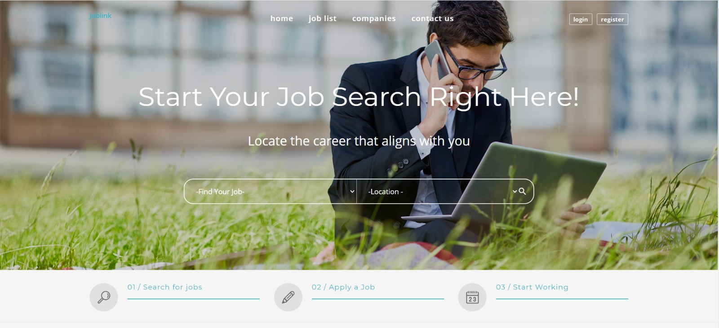

Figure .: Home Page

**2. Admin Page:** As an admin, logging into the website via the login interface will be directed to a home page including all powers of admin can do as shown in Figure ‎4.2. Admin powers are a lot, most notable are managing and monitoring organization. First, admin can edits users by approving and disapproving, deleting a user ( employee or employer ), and adding a user. Second, he can edit the categories by adding and deleting. Also, he can view website data like posted advertisement from employee and employer. Moreover, admin can see contact us messages and delete an of them. Finally, he can view users data and profiles, adding on this he can see analytics graphs about the website weekly, monthly…

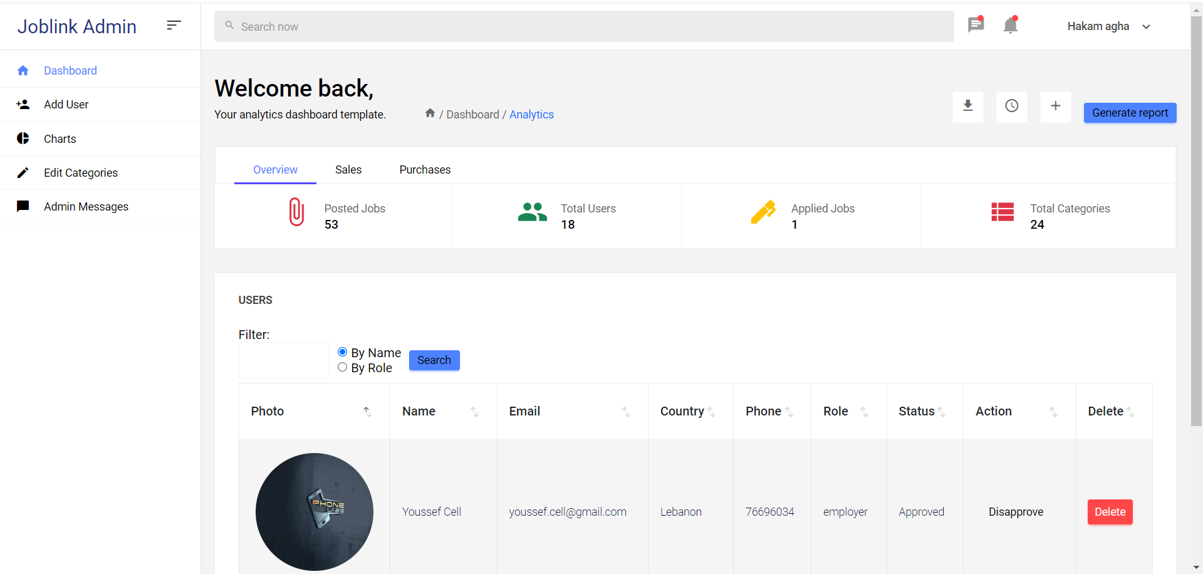

Figure ‎4.2: Admin Home Page

**3. Job List Page:** A user can access job list for searching for a job filtering the search by category, country, type of job and min salary. In common all users can enter this page. A guest can’t apply for a job while registered user as employee can apply for any job listed in this page according to his location and speciality.SQL is responsible for retrieving and managing the job data from the database, ensuring that the listings displayed are accurate and relevant. PHP dynamically generates the job list page, processes user interactions, and manages sessions, ensuring that the page is responsive and personalized for each user, as shown in Figure ‎4.3.

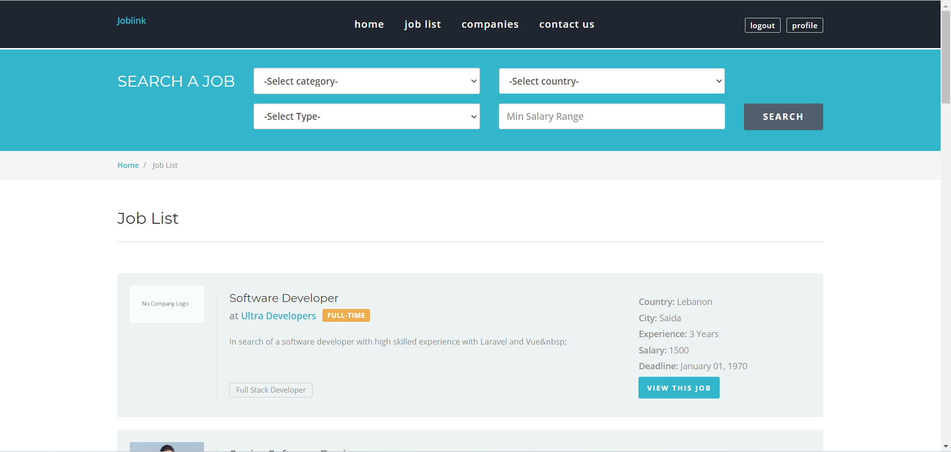

Figure ‎4.3: Job List Page

**4. Employer**: This page includes all registered companies to the platform. All users can access registered companies by a simple click. Through this page, the user can search for a specific company whether it is registered on the page, and after that user can benefit from submitting an employment application, refer to Figure ‎4.4.

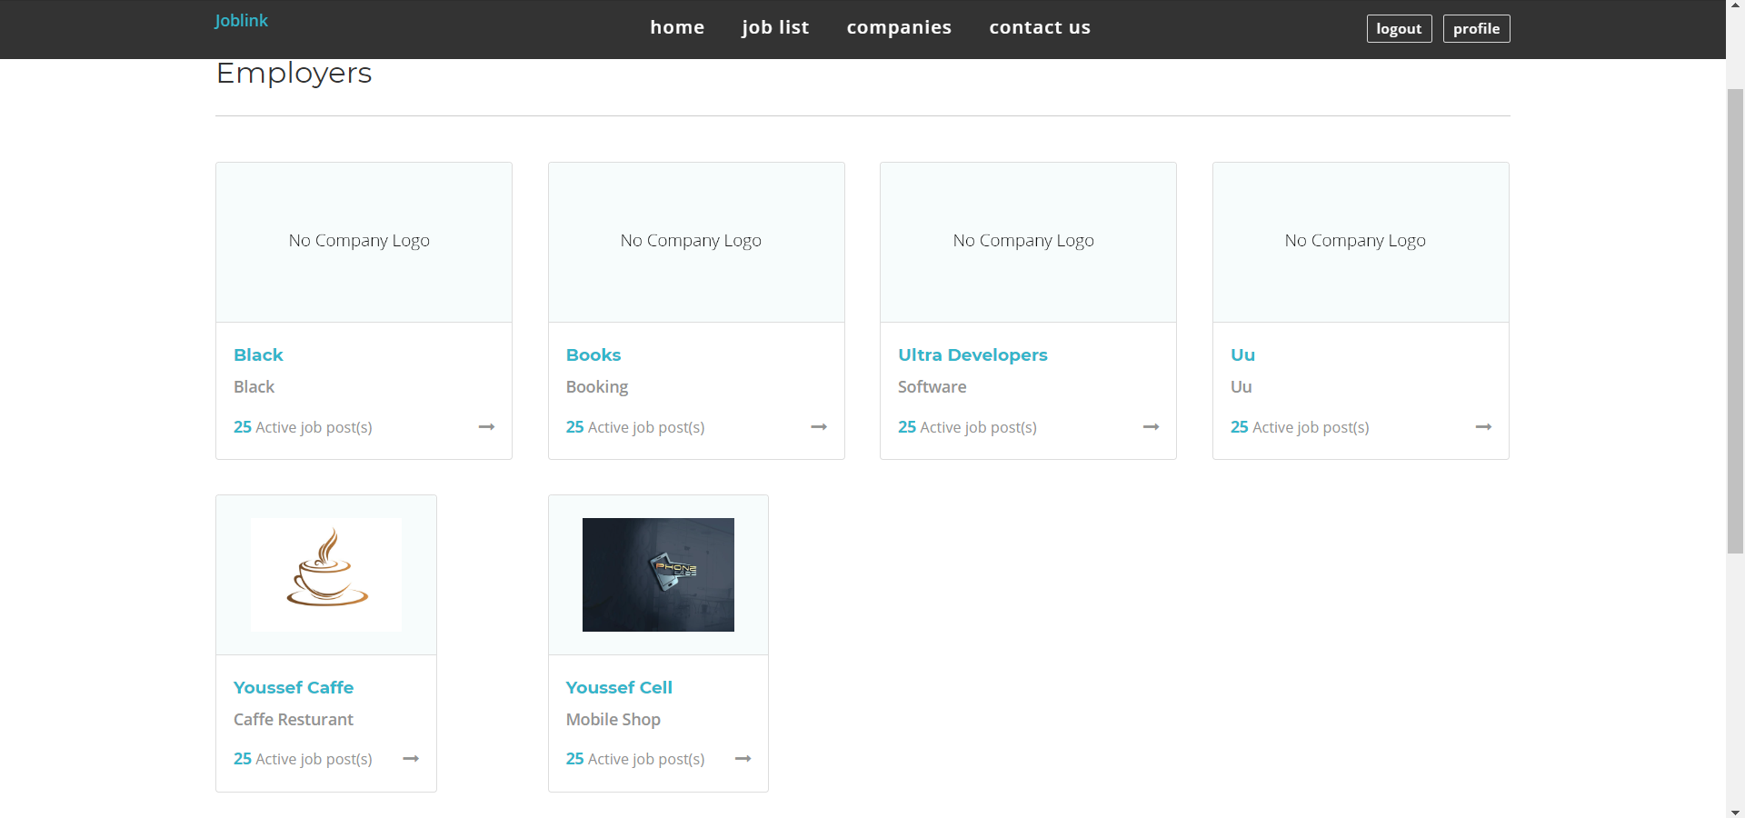

Figure ‎4.4: Employers Page

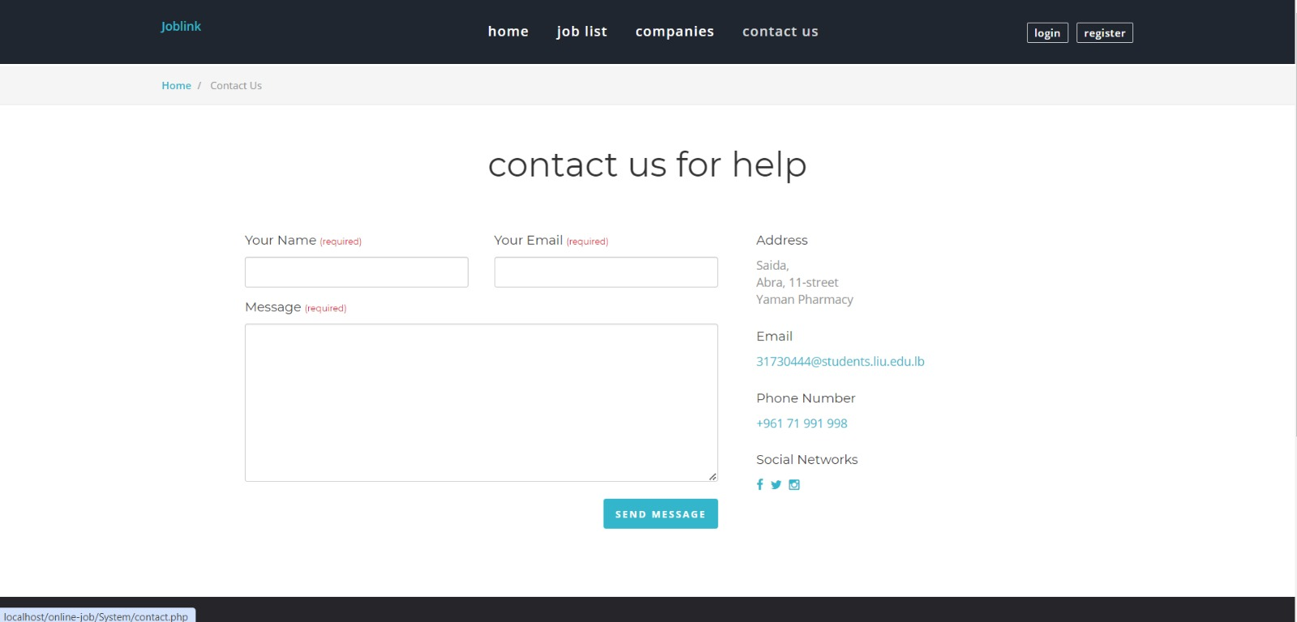**5. Contact us**: If there is any problem that requires communicating with the admin, for example: the user cannot register for some reason, he can contact the admin to solve this problem and other problems, refer to Figure ‎4.5.

Figure .: Contact Us Page

**6. Registration Page**: As employee users can create a new account by signing up and inserting required credentials as shown in Figure ‎4.6 otherwise, another form of data inputs which includes company information required for an employer to register as shown in Figure ‎4.7 adding a file to upload belongs to the company. Also when registration is done a message will appear “ you have been registered successfully “ as shown in Figure ‎4.8 SQL is responsible for storing and validating the registration data in the database, ensuring that new accounts are unique and securely saved. While PHP handles form processing, input validation, secure data handling (such as password hashing), and interaction with the SQL database, making sure that the registration process is smooth, secure, and user-friendly.

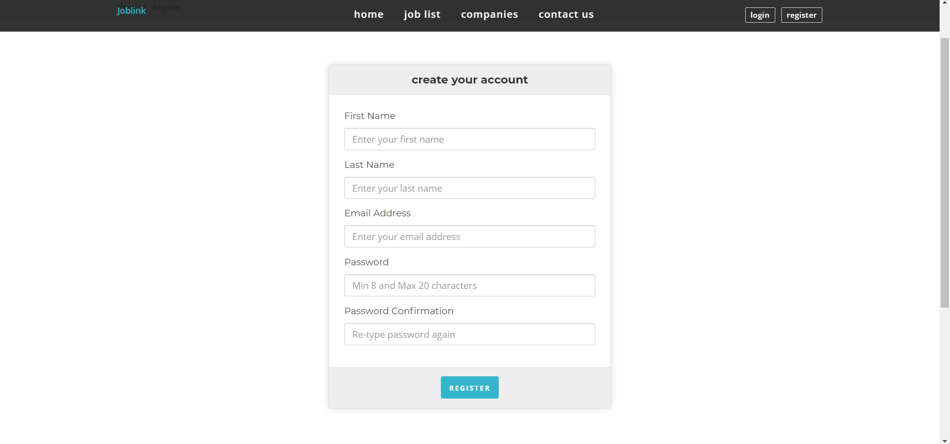

Figure ‎4.6: Employee Registration Page

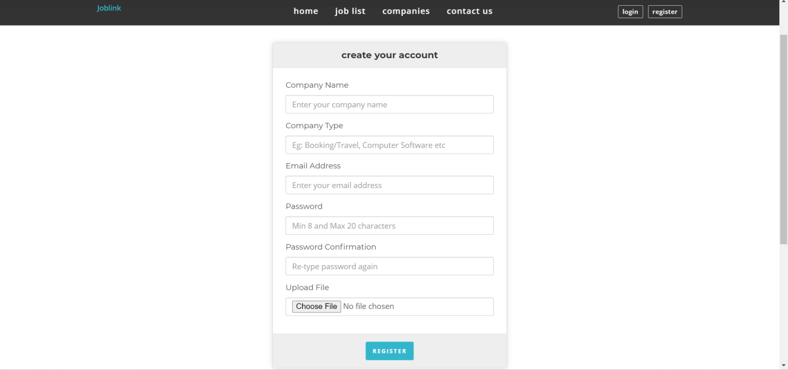

Figure ‎4.7: Employer Registration Page

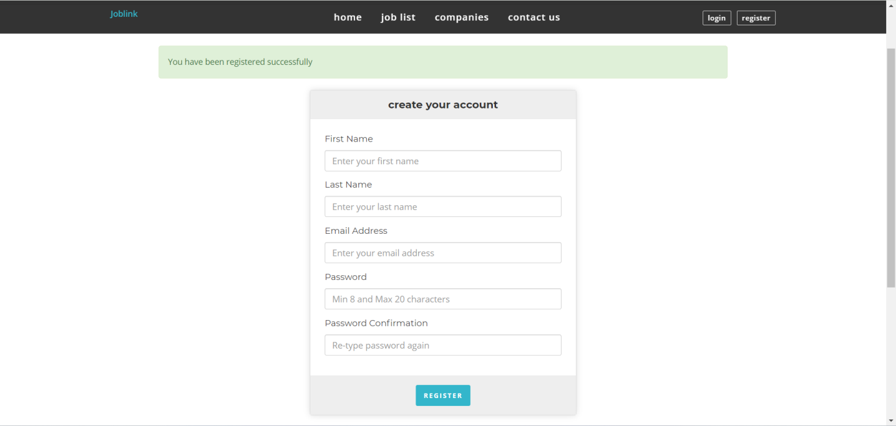

Figure ‎4.8: Successfully Registered

**7. Login Page:** To access JobLink platform, a job seeker can go directly to the login page so that he can apply for available jobs. He can also edit personal file, change password and communicate with employers. To login he must be registered. As an employer user can modify company information as location, specialty and post a job. In both cases employee or employer, users can reset password in case of they forget the password. As shown in Figure ‎4.9. Signing in demands the username and password from the user. The PHP codes and MySQL database determines the type of user who signed in. Afterwards, the user will be 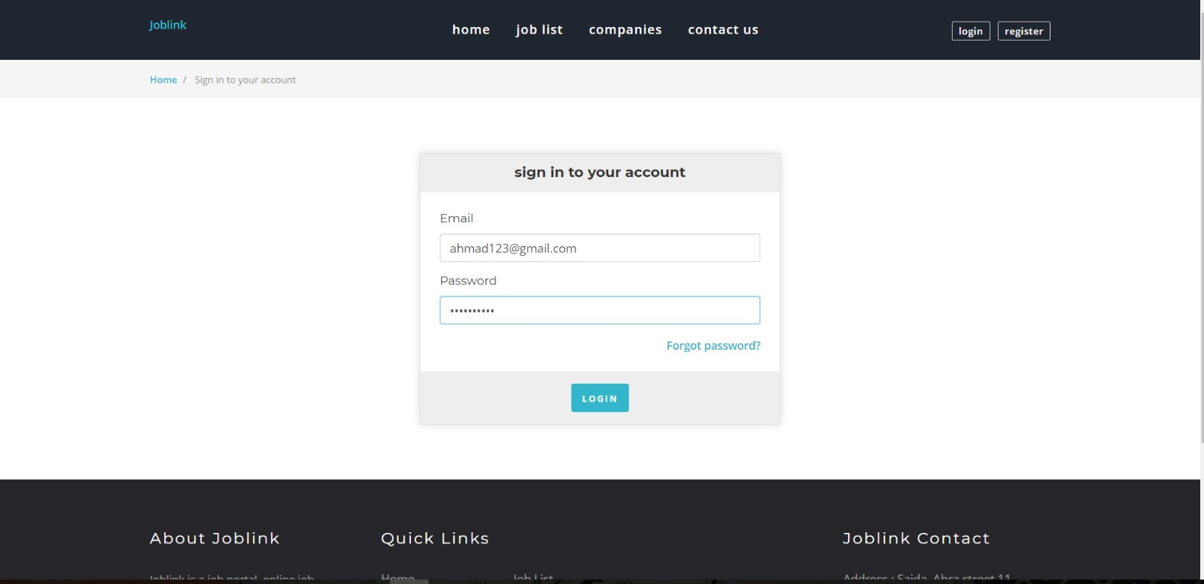directed to his home page regarding his user type: Employee or Employer.

Figure .: Login Page

**8. Employee Profile Page**: Logging in as an employee, user can access his profile page that show all personal information as name gender and phone number and more, it includes also all data related to the resume of the user as professional qualification, education, language, skills, work experiences and a profile photo. The user can also check which jobs he has previously applied for. The PHP codes and MySQL database determines the type of user who signed in, so data directly related to an employee by a specific ID, then profile page can be accessed and all data will be modified and imported simultaneously and saved to a specific server. SQL handles the storage and retrieval of user profile data, while PHP facilitates the interaction between the user and the database, allowing for the viewing, updating, and 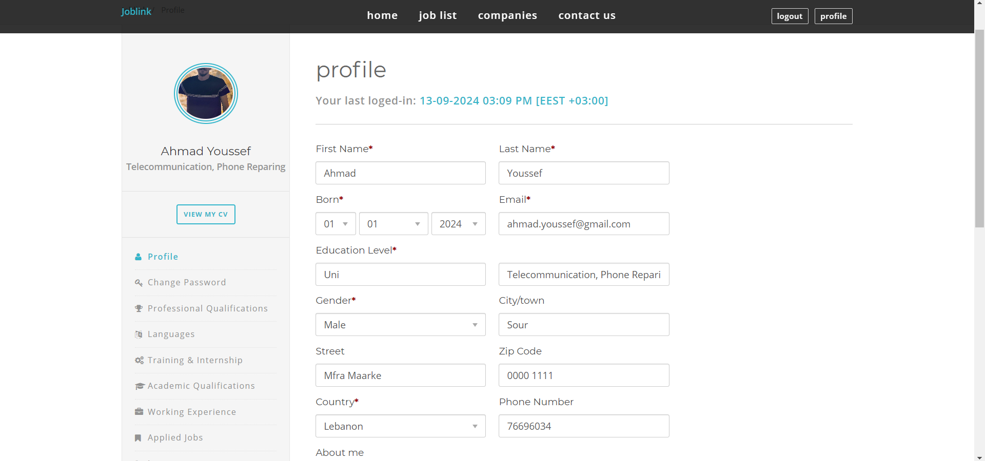management of profile information on the recruitment platform, as shown in Figure ‎4.10.

Figure .: Employee Profile Page

**9. Apply Job Page**: This page contains all posted job descriptions such as responsibilities and requirements as shown in Figure ‎4‑11. After verifying that all information is correct, the User can make a simple click to apply for the job as shown in Figure ‎4‑12and a message “ you have successfully applied this job “ will appear. The User can also check the applied job attached with the date and time as shown inFigure ‎4‑13

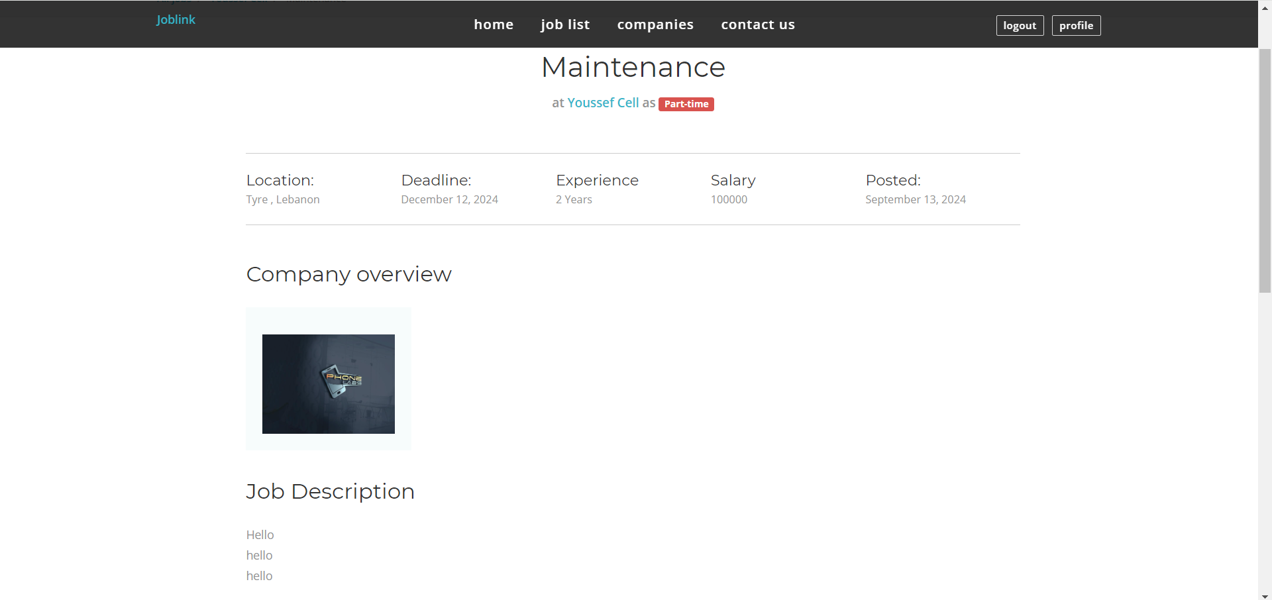

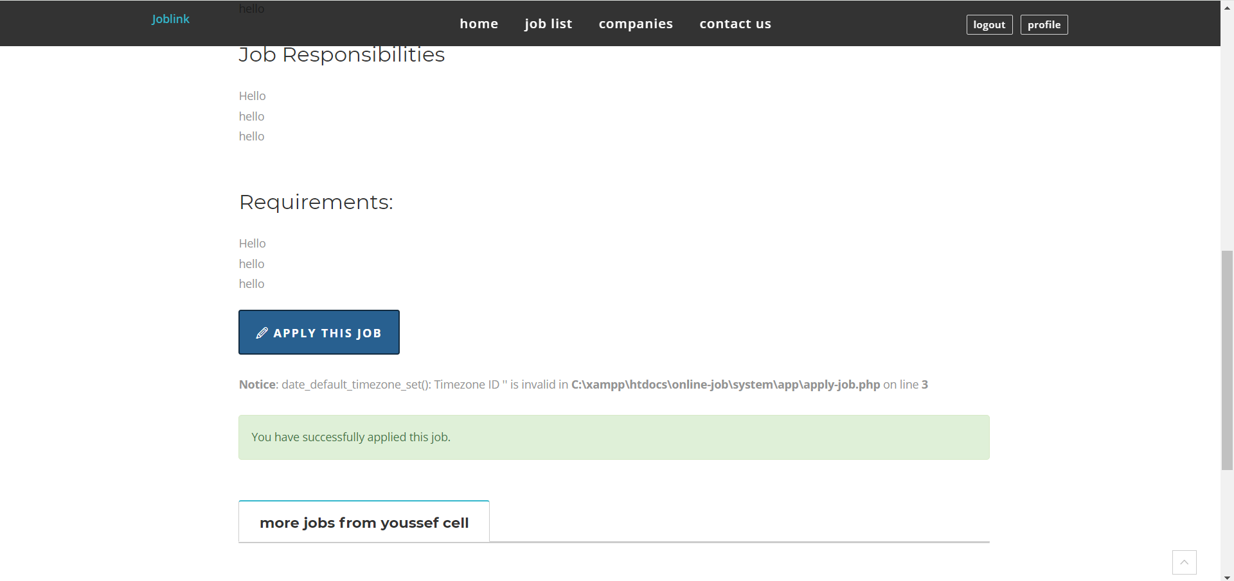Figure ‎4.11: Apply Job Page 1

Figure ‎4.12: Apply Job Page 2

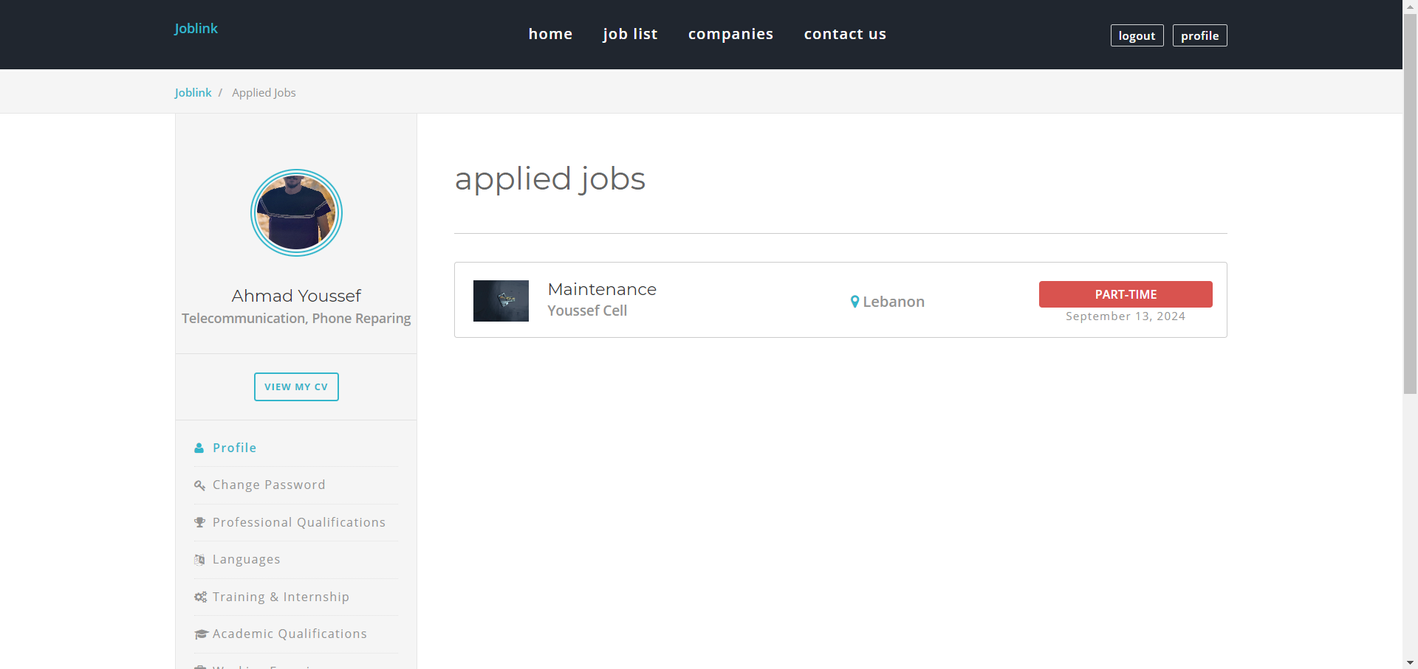

Figure ‎4.13: Applied Job Page

**10. Employer Profile Page**: Logging in as an employer, the user can access his profile page that shows all personal information such as name gender, phone number, and more, it includes also all data related to the company such as company name, establishing date, location, email, phone number, and specialty... The user can also check which jobs have previously been posted. The PHP codes and MySQL database determines the type of user who signed in, so data directly related to an employer by a specific ID, then profile page can be accessed and all data will be modified and imported simultaneously and saved to a specific server, refer to Figure ‎4.14.

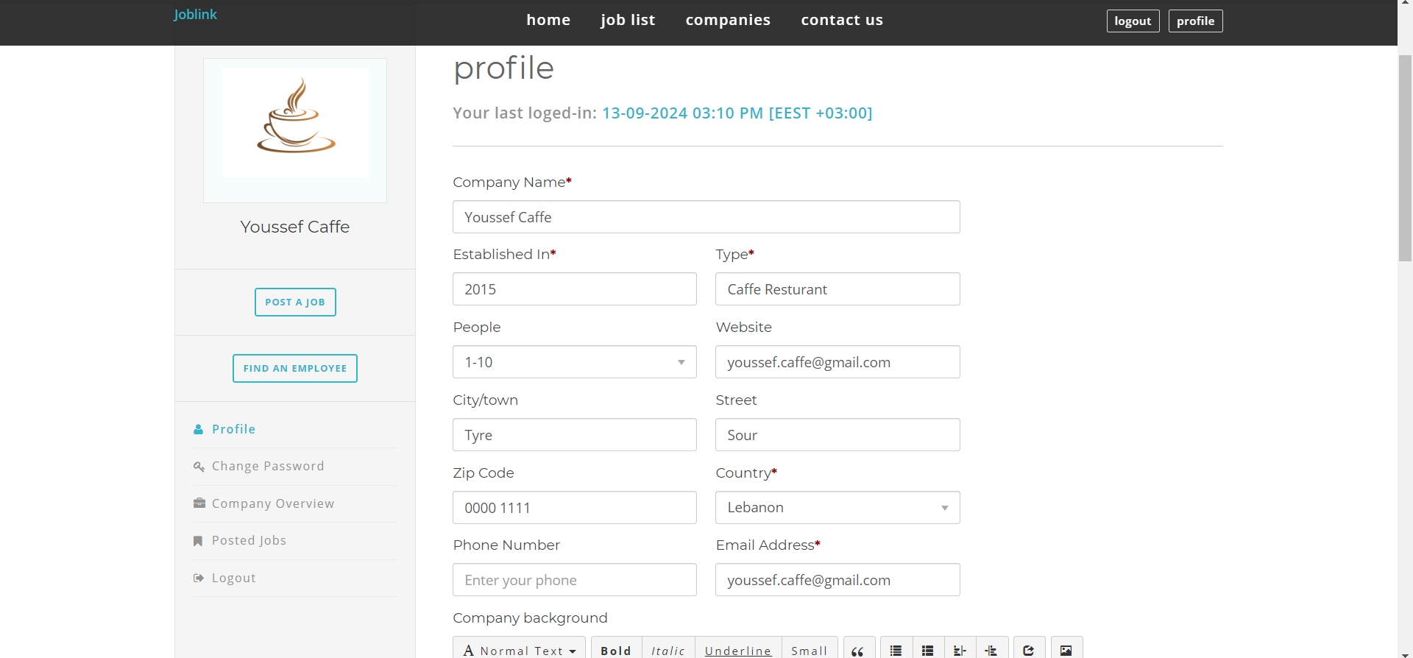

Figure ‎4.14: Employer Profile Page

**11. Job Post Page**: On the job posting page of a recruitment platform, employers can easily create and publish job listings to attract suitable candidates. This page typically features a user-friendly interface where employers can input job details, such as the title, description, required qualifications, and salary range. Employers can also specify the job location, type (full-time, part-time, remote), and application deadline as shown inFigure ‎4.15**.** On the other side,employer can check the posted job and user applied to the job and also he can modify the job description and details, or even delete the job as shown inFigure ‎4.16**.** SQL manages the job-related data storage and retrieval, while PHP facilitates the interaction between the job post webpage and the database, allowing employers to create, update, and manage job listings effectively

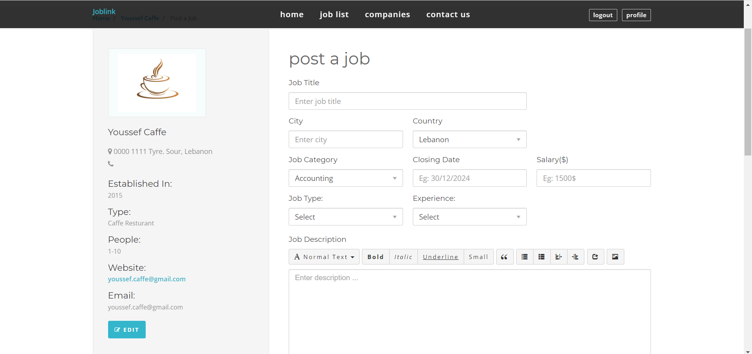

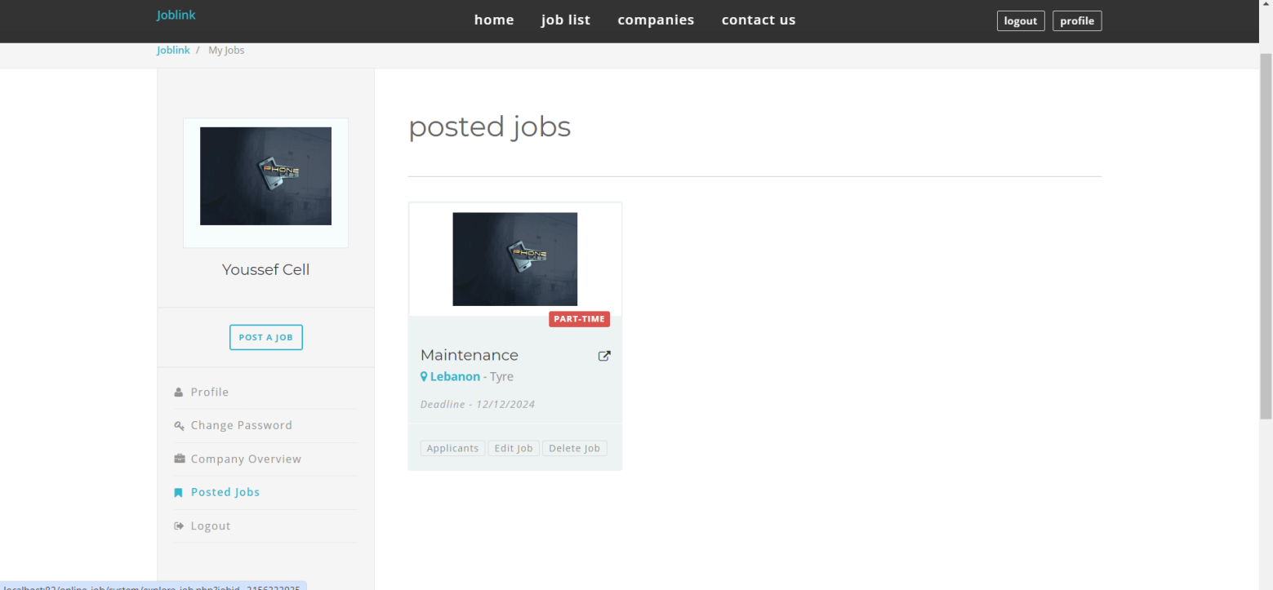Figure ‎4.15: Job Post Page

Figure ‎4.16: Posted Job Post Page

**12. Job Applicant Page**: As an employer user can check all applied users for a specific open job. Moreover, employer can look over jobseekers profile and all specific details related to the user(employee). Also, these details remains confidential and can only be seen be the employer to whom you applied. It is not available to other users, whether they are an employers or job seekers. SQL handles the data management, while PHP processes the logic and facilitates communication between the user interface and the database, ensuring a functional and responsive applicant webpage, refer to Figure ‎4.17.

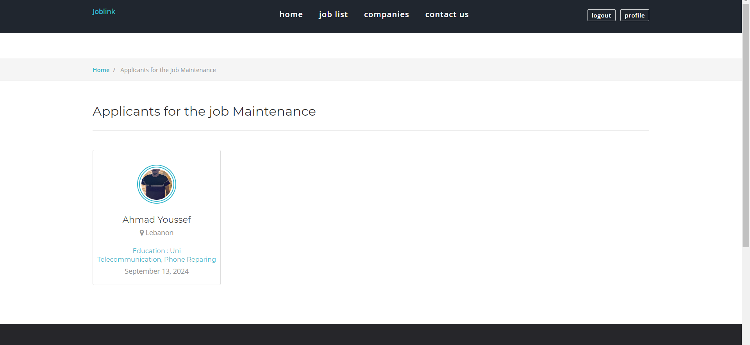

Figure ‎4.17: Job Applicant Page

**13. Employee Details**: By clicking on a specific user icon in the job applicant page, employer will be redirected to a new web page related to employee details such as resume which includes specialty, address, experiences, skills and personal information, refer to Figure ‎4.18.



Figure ‎4.18: Employee Details Page

**14.** **Change/Recover password:** Any user employee or employer can change and recover his password, by clicking by change password button as shown in Figure ‎4.19.

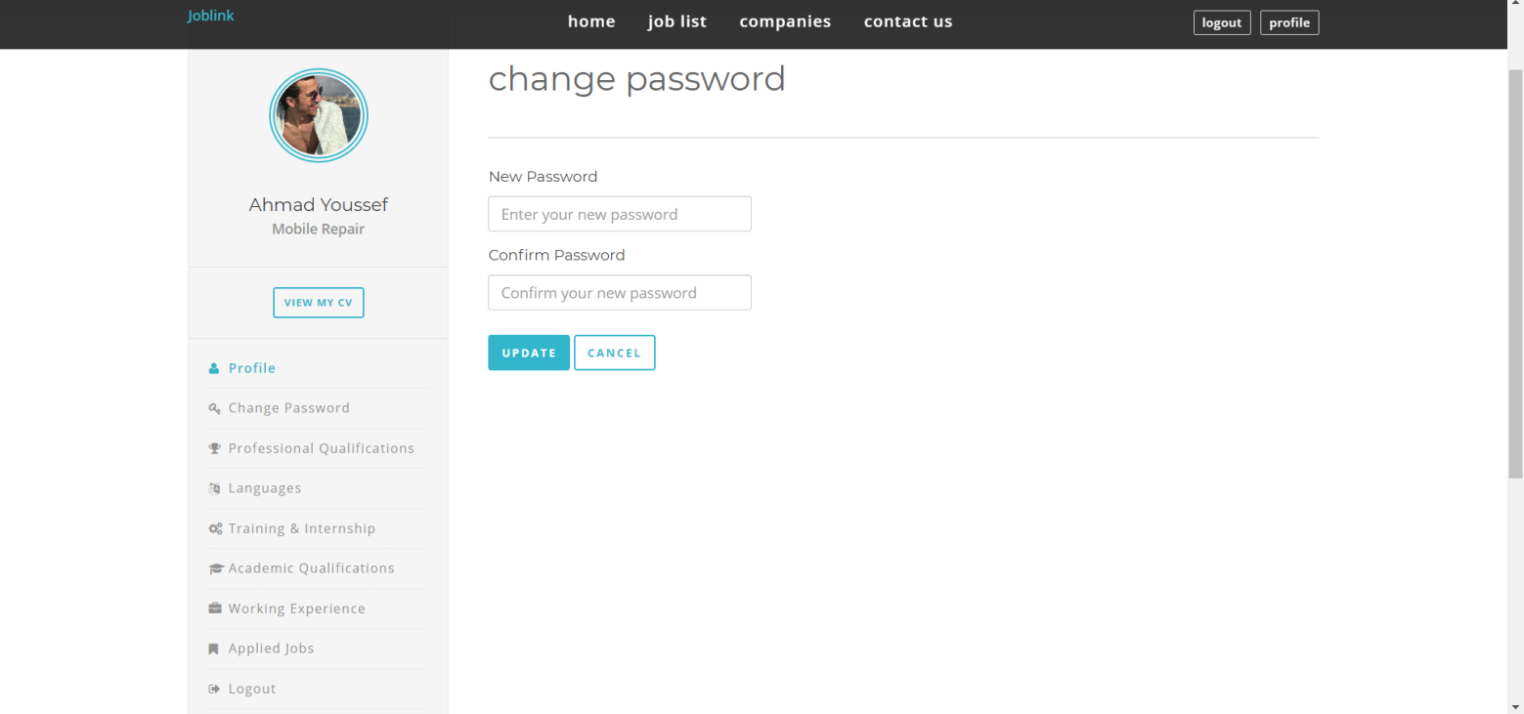

Figure .: Change/Recover Password Page As Employer

**15.** **Find Employee:** As an employer you can go to page find an employee to search by filtering and selecting category, country and Min Experience Years as shown in Figure ‎4.20.

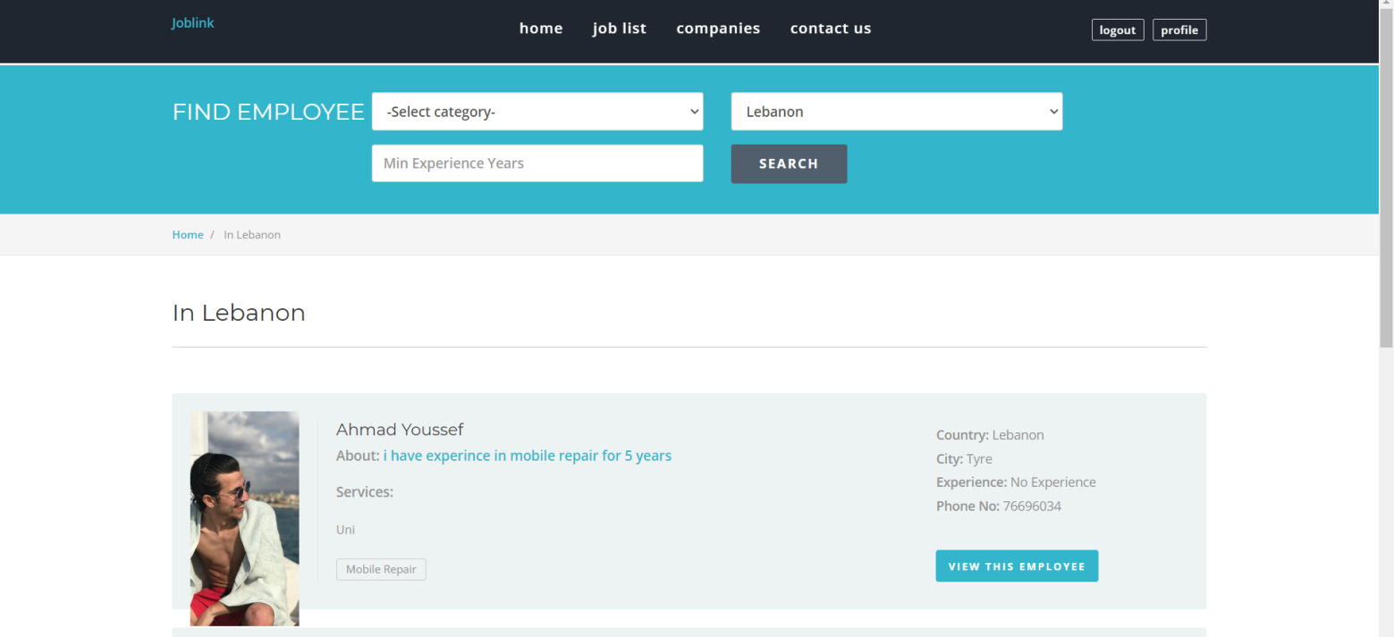

Figure .: Find Employee Page

**16. Charts Analytics:** As an admin, you can see line charts and bar charts. Line charts are to display registration increasing for each year and bar charts display each country's users number as shown in Figure ‎4.21.

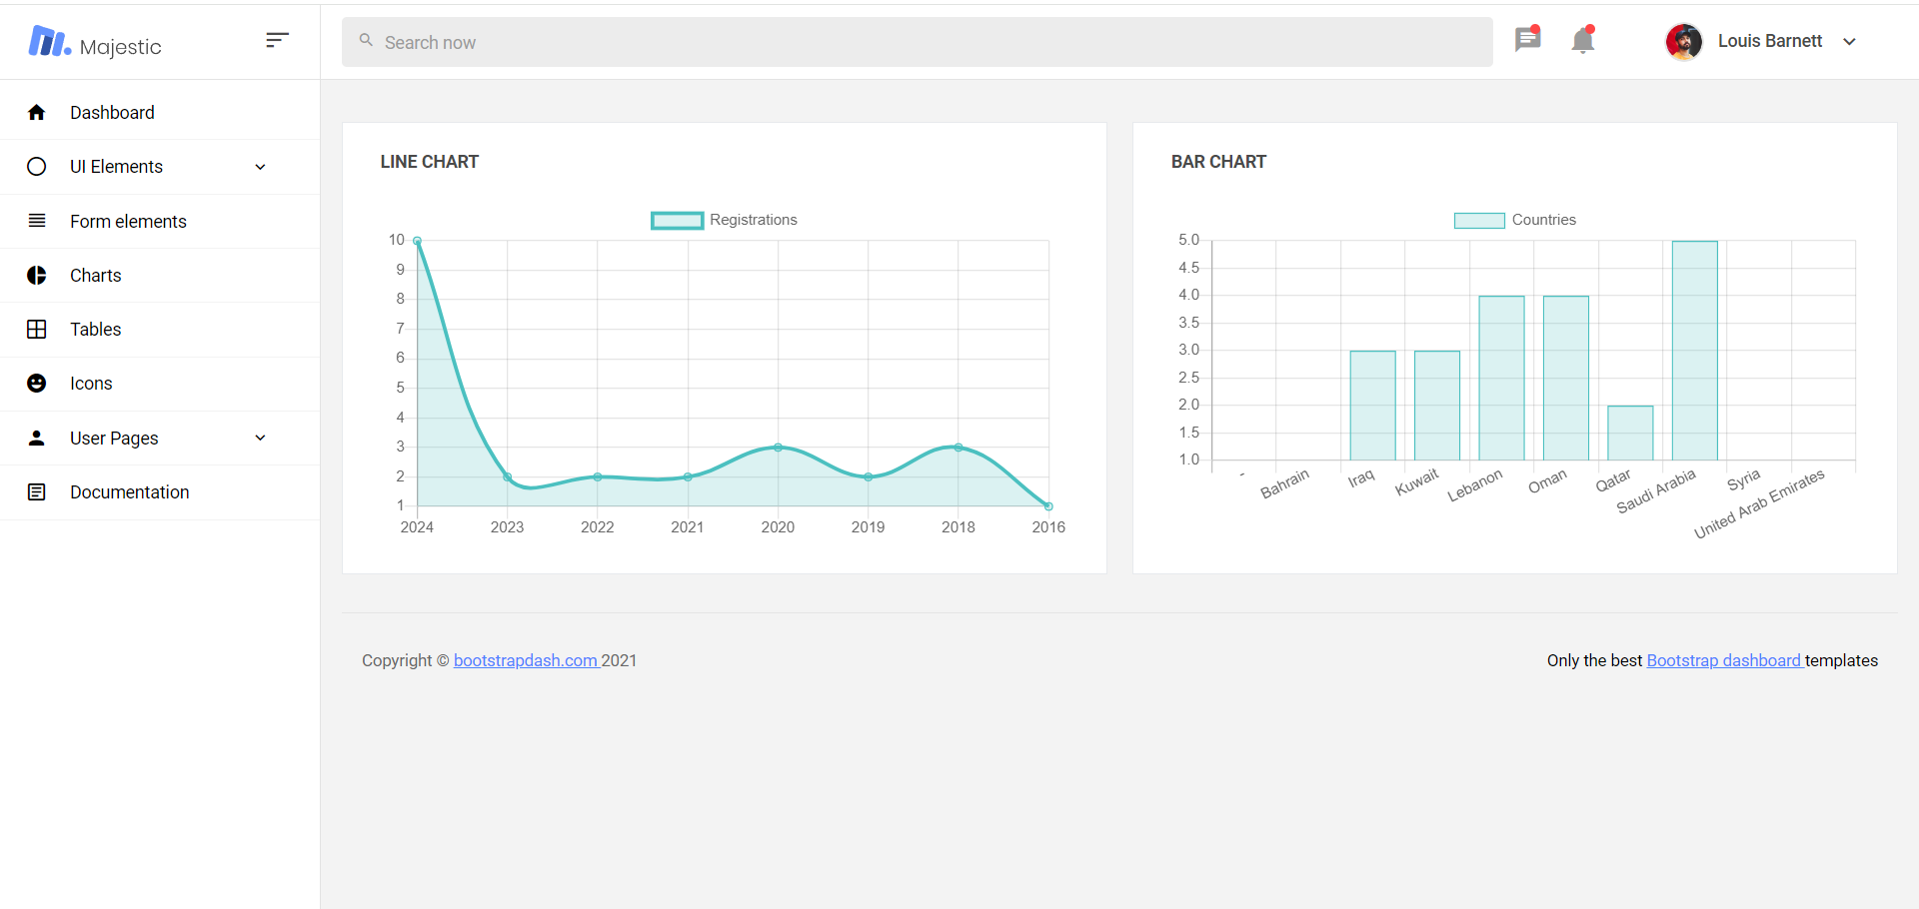

Figure ‎4.21: Admin Charts

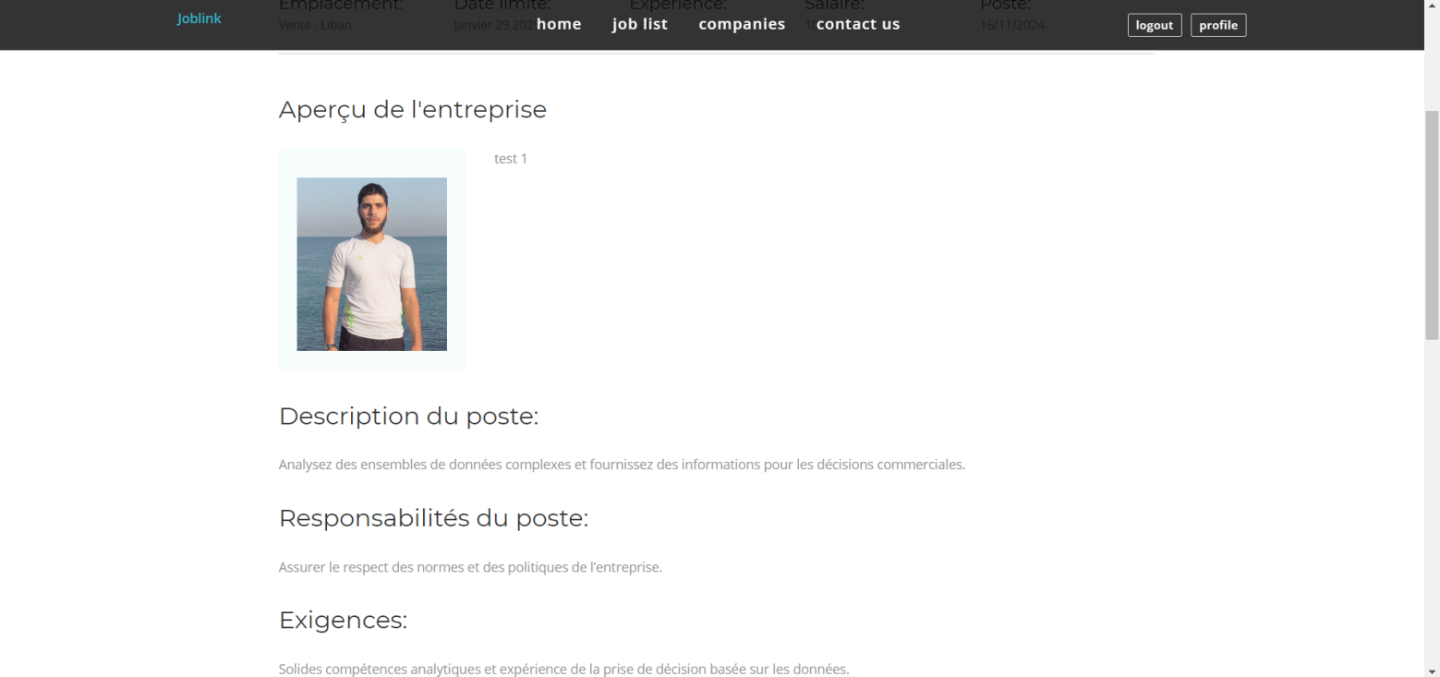**17.Ai Translation:** Going to job list and choosing an job you can translate all the page to ARABIC as shown in Figure ‎4.22, FRENCH as shown in Figure ‎4.23 and the original language is ENGLISH as shown in Figure ‎4.24. You can find this option right at top of the page as shown in Figure ‎4.25.

Figure .: French Language

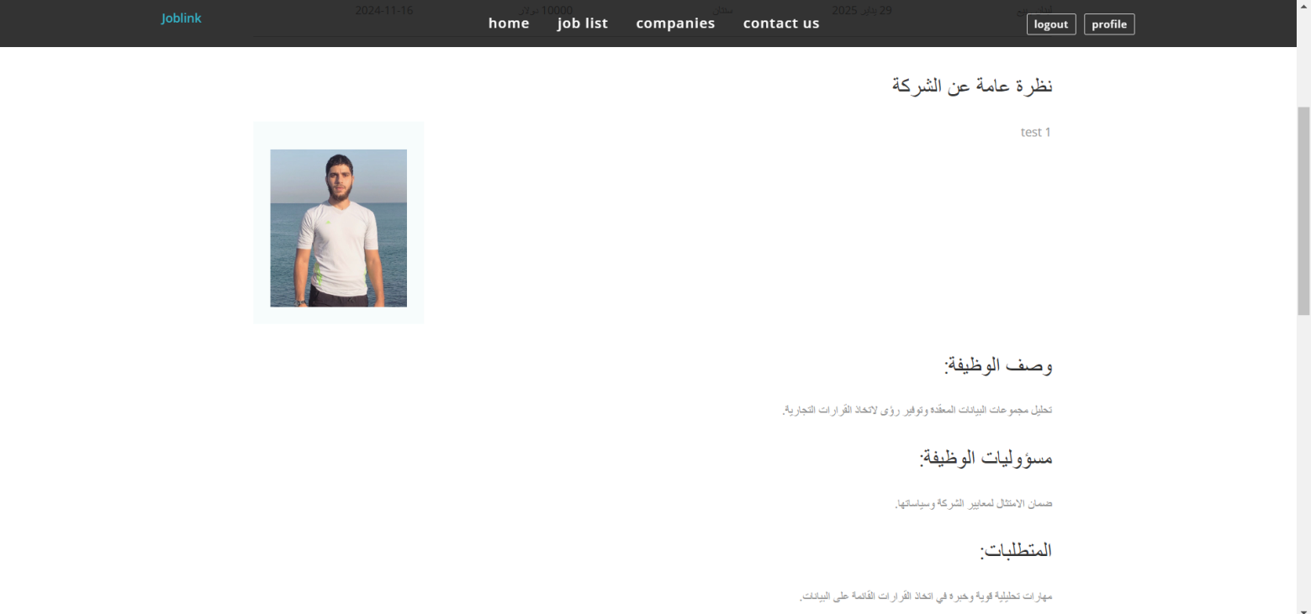

Figure .: Arabic Language

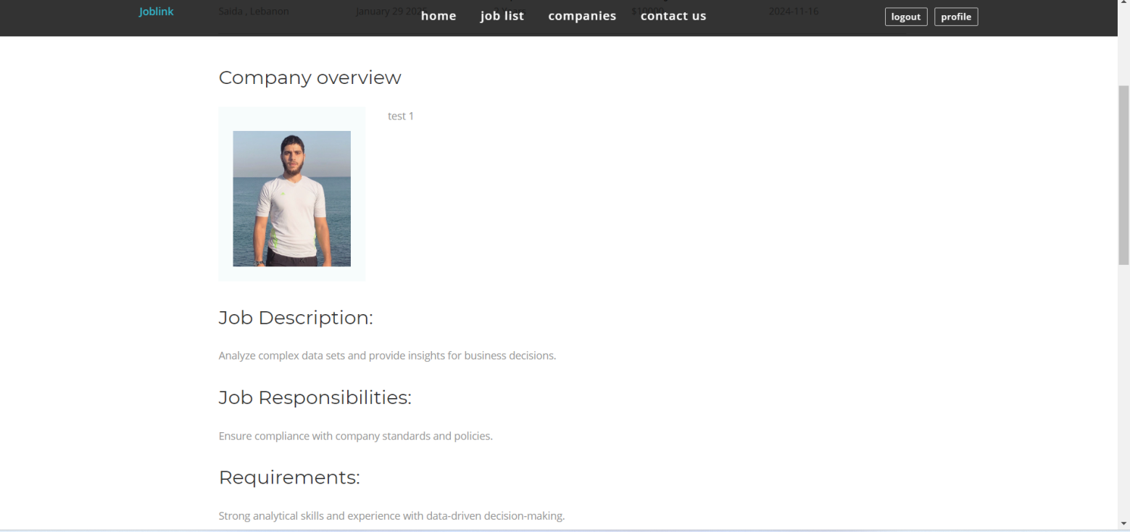

Figure .: English Language (Original)

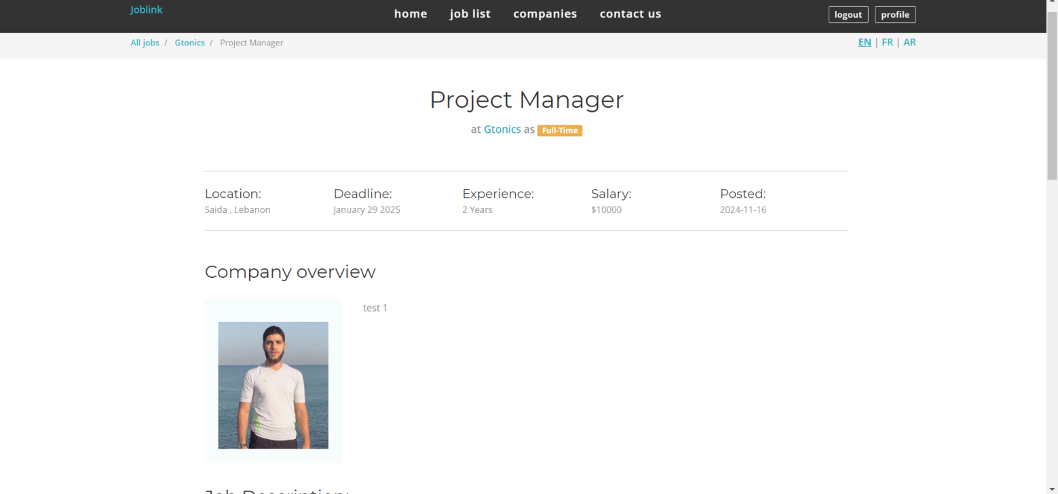

Figure .: Ai Translation At Right Top

## Test Cases and Acceptance Criteria

In the previous section, we presented the implementation of the website and how users are directed from one page to another. However, this section presents the interaction of the web system in case of wrong actions.

**Test Case 1: Login Functionality**

Test Steps:

* Enter a valid username and password.
* Click on the login button.
* Verify that the user is successfully logged in and redirected to the home page.
* As employer at default all new registered employer are disapproved.

Acceptance Criteria:

* The user should be able to log in with valid credentials.
* After successful login, the user should be directed to the home page.

Case of failure:

* Users insert an email address that does not exist, a message ( invalid email or password ) appears, as shown in Figure ‎4.26.
* Users insert a wrong password, a message ( invalid email or password ) appears, as shown in Figure ‎4.26.
* Employer is not approved, a message ( you need admin approval ), refer to Figure ‎4.27.

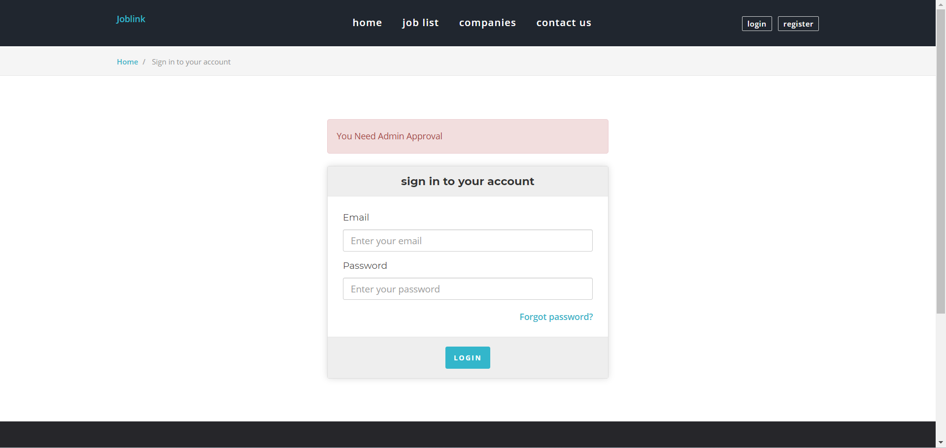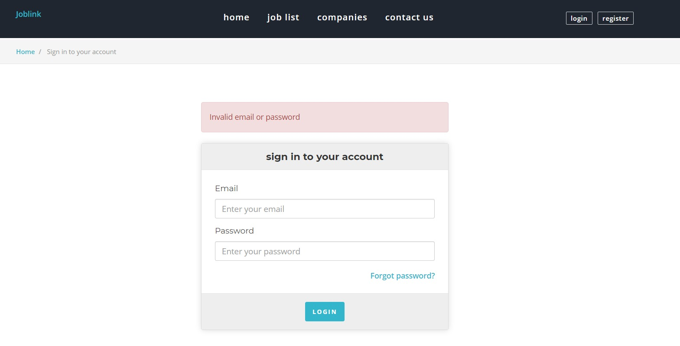

Figure .: Wrong Credentials

Figure ‎4.27: Logging In With Admin Approval Message

**Test Case 2: Editing Employee/Employer Profile**

Test Steps:

* Logging in as an employee/employer, the user can access his profile page that shows all personal information

Acceptance Criteria:

* User can edit their profiles such as name, gender, phone number, and more…
* The profile also includes also all data related to the company such as company name, establishing date, location, email, phone number, and specialty...

Case of failure:

* If the user skips any of the required details empty, a message ( Please fill out this field ) appears below the skipped part, refer to Figure ‎4.28 and Figure ‎4.29.

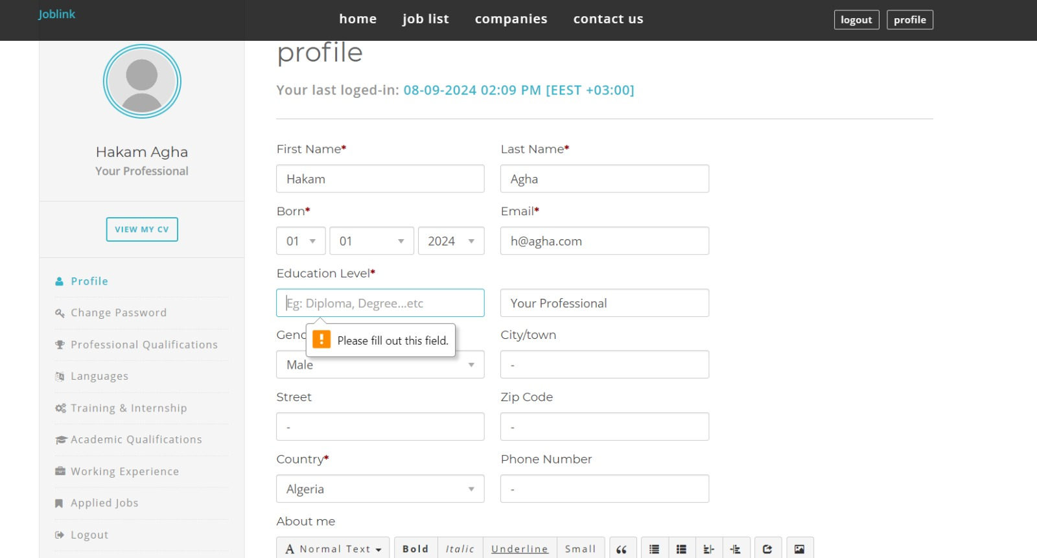

Figure .: Editing Employee Profile

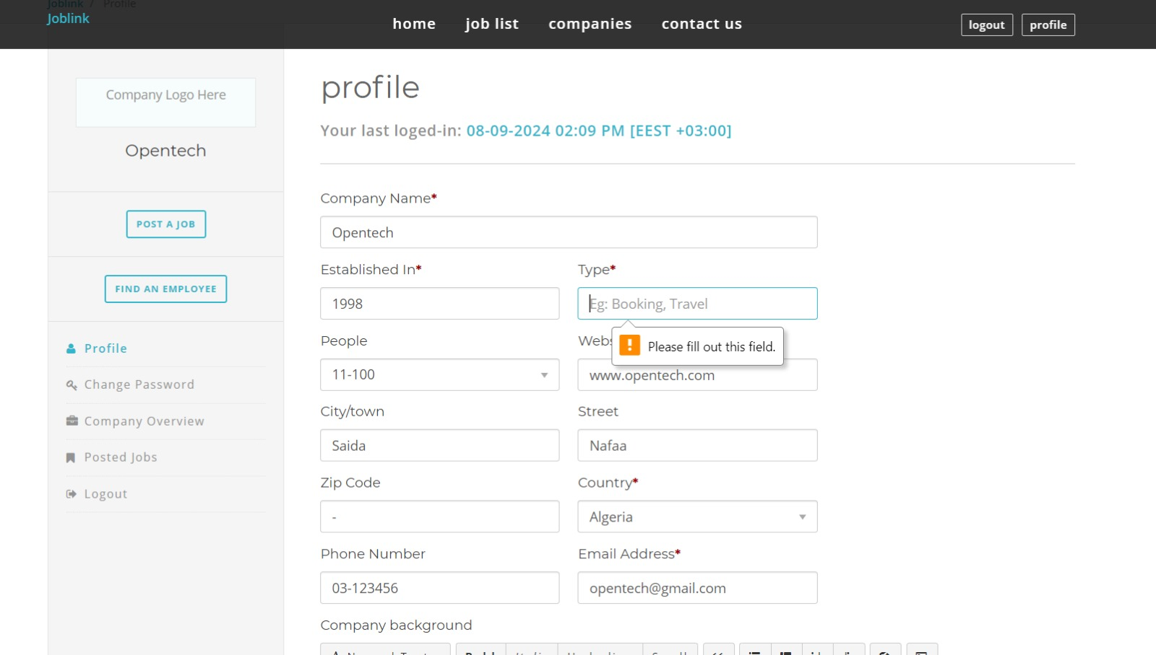

Figure .: Editing Employer Profile

**Test Case 3:** **Registration As Employee**

Test Steps:

* Provide the required details such as First Name, Last Name, Email, and Password.
* Click on the "Register" button.
* Verify that the registration is successfully created.

Acceptance Criteria:

* The user should be directed to his home page regarding his user type: Employee or Employer.

Case of failure:

* If the user skips any of the required details, a message ( Please fill out this field ) appears below the skipped part, as shown in Figure ‎4.30.

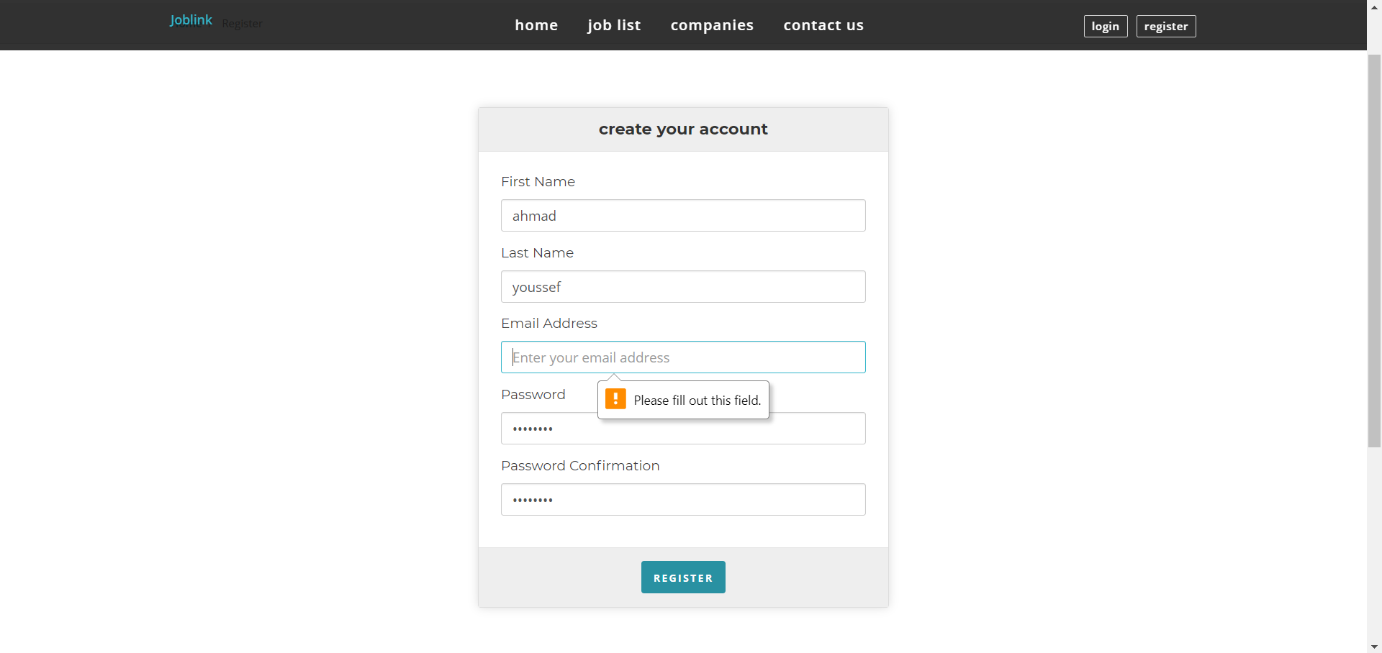

Figure .: Employee registration

**Test Case 4:** **Registration As Employer**

Test Steps:

* Provide the required details such as Company Name, Company type, Email, and Password.
* Click on the "Register" button.
* Verify that the registration is successfully created.

Acceptance Criteria:

* The user should be directed to his home page regarding his user type: Employee or Employer.

Case of failure:

* If the user skips any of the required details, a message ( Please fill out this field ) appears below the skipped part, as shown in Figure ‎4.31.

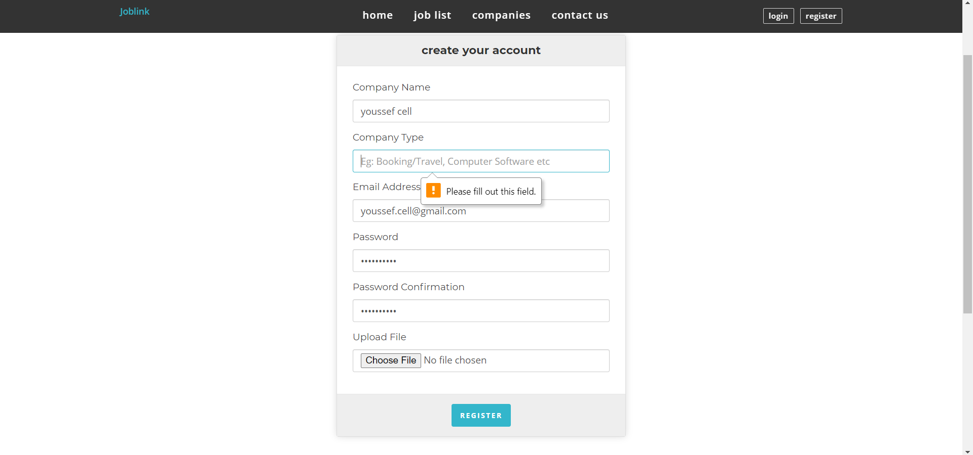

Figure ‎4.31: Employer Registration

**Test Case 5: Posting Job**

Test Steps:

* Provide the required details such as Job title, Company type, Experience, and Job description...
* Click on the "Post" button.
* Verify that the posting is successfully done, by going to posted jobs page.

Acceptance Criteria:

* The user should be directed to posted job page.

Case of failure:

* If the user skips any of the required details, a message ( Please select an item in this list ) appears below the skipped part, as shown in Figure ‎4.32.
* If the user don’t fill a required field, a message ( please fill out this field ) as shown in Figure ‎4.33.

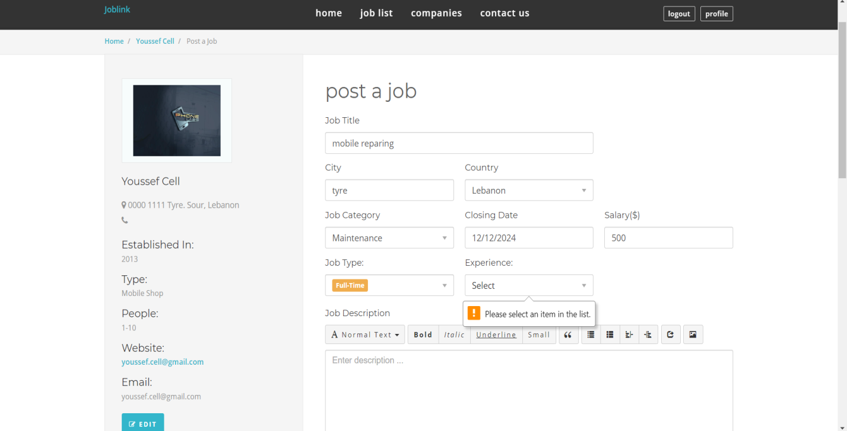

Figure ‎4.32: Job Post Page 1

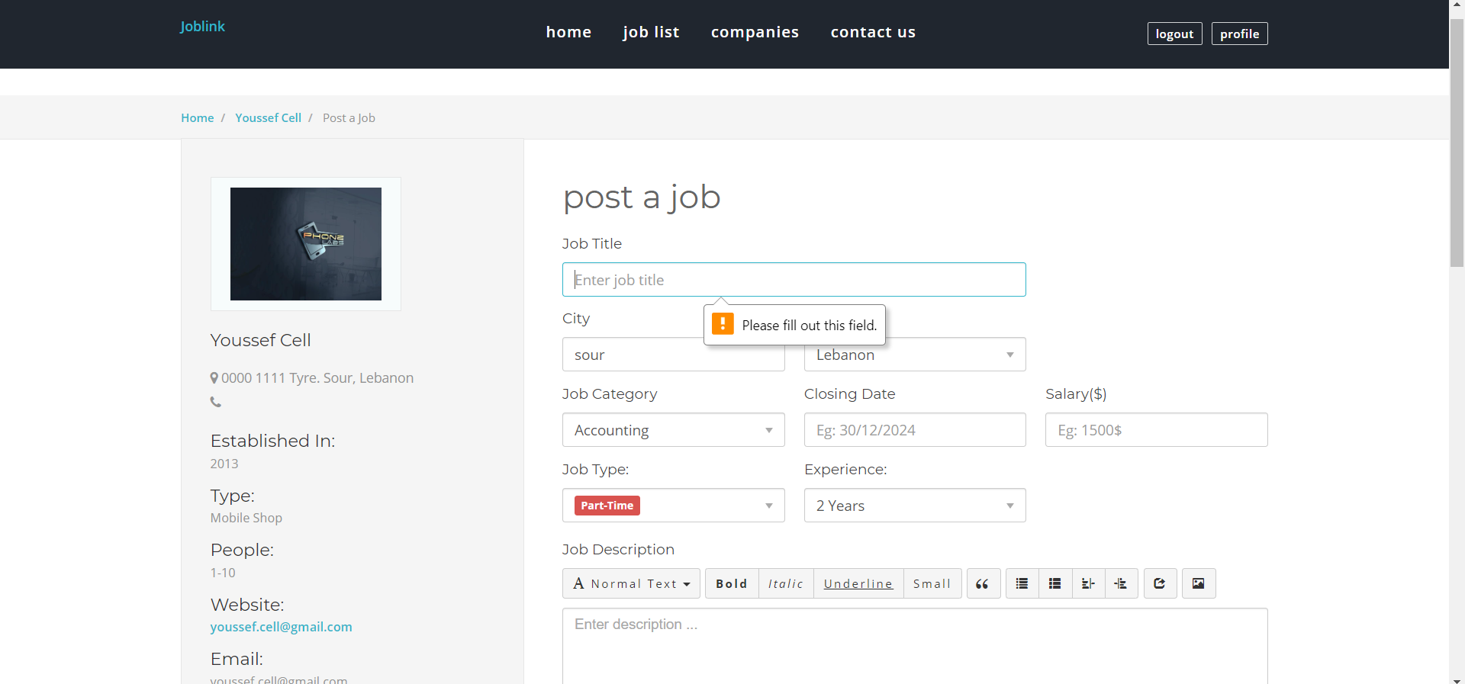

Figure ‎4.33: Job Post Page 2

**Test Case 6: Contact Us**

Test Steps:

* Provide the required details such as your name, your email, and your message.
* Click on the "send message" button.

Acceptance Criteria:

* Verify that the sending is successfully done, by popping up a message ( your message was sent successfully ).

Case of failure:

* If the user skips any of the required details, like name our email, a message ( your name is required or your email is required and must be valid email address ) appears below the skipped part, as shown in Figure ‎4.35.
* 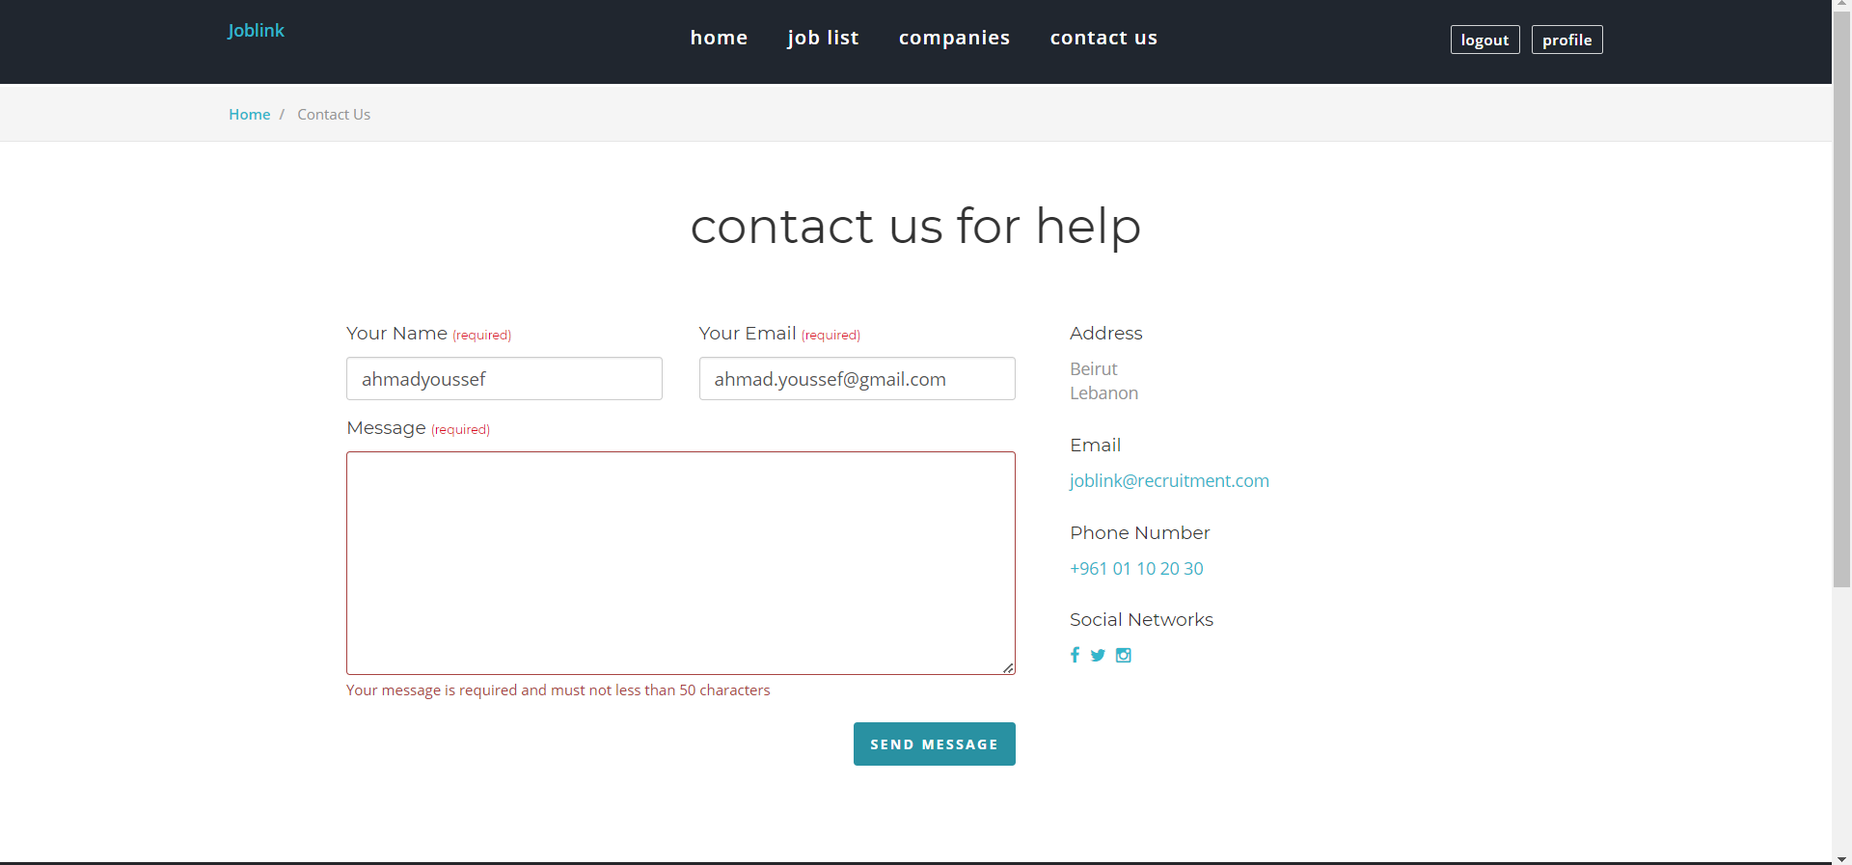If the user don’t fill the message part, a message (your message is required and must not less than 50 characters ) as shown in Figure ‎4.34.

Figure ‎4.34: Missing message part

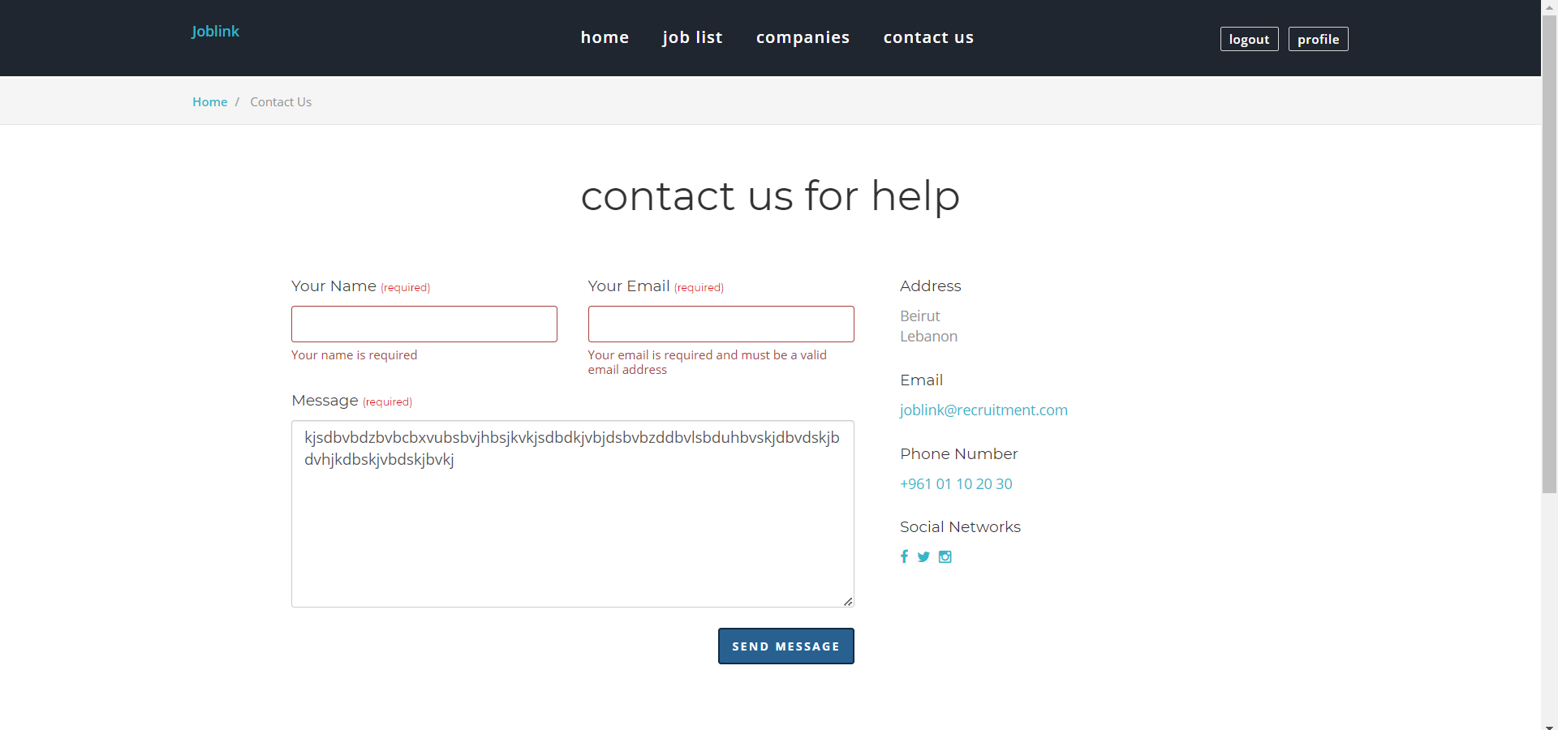

Figure ‎4.35: Missing name or email part

## Conclusion

In conclusion, the implementation phase of the job seeker website has been a critical step in ensuring its functionality and reliability and was executed successfully utilizing JavaScript, HTML, PHP, and MySQL as the primary languages. These languages were chosen for their familiarity, platform suitability, extensive ecosystems, and adherence to industry standards. Through meticulous development and rigorous testing, the website has been refined to meet user needs effectively, with a focus on intuitive design and seamless performance. The testing phase not only identified and resolved potential issues but also validated the site's features, confirming its readiness for real-world use. The successful deployment of the website represents a significant achievement, laying a strong foundation for job seekers to connect with opportunities efficiently. Moving forward, ongoing monitoring and updates will be essential to adapt to user feedback and evolving industry standards, ensuring the website remains a valuable tool in the job market.

# Conclusion and Future Work

## Conclusion

The development of the job seeker website has been an invaluable learning experience, shedding light on the complexities of creating a digital platform tailored to the needs of job seekers and employers alike. Despite encountering challenges such as resource constraints and evolving requirements, we successfully built a functional and user-centric website that facilitates efficient job matching and application processes. This project underscored the importance of prioritizing user needs and preferences, ensuring that the platform is both accessible and effective.

One of the key insights gained was the critical role of effective communication and collaboration. By maintaining open dialogue and sharing expertise, our team navigated various obstacles and successfully met project goals. This experience highlighted the significance of teamwork and coordination in achieving a successful outcome.

Furthermore, the development process provided us with valuable experience in web development, user interface design, and database management. We honed our skills in creating intuitive interfaces, optimizing performance, and implementing robust data-handling practices. The importance of continuous improvement was emphasized through user feedback, usability testing, and ongoing performance monitoring.

Overall, this project has demonstrated that with careful planning, adaptability, and a collaborative approach, significant achievements are possible. Despite the challenges faced, we overcame hurdles and made substantial progress, positioning the website for a promising future and continued success in helping job seekers connect with opportunities.

## Future Work

Expanding on the work done in the Jobseeker website thesis opens up numerous exciting opportunities for future development. Integrating advanced algorithms and AI could offer personalized job recommendations, tailored content, and dynamic search filters based on user behavior and preferences. Implementing sophisticated analytics tools would provide employers with deeper insights into candidate engagement and site performance, potentially incorporating features like heat maps. Exploring machine learning models could enhance resume parsing, skill matching, and job suggestions while developing social media integration would facilitate easy job sharing, profile synchronization, and networking. Introducing interactive elements such as career planning tools and virtual job fairs could boost user engagement, and expanding into a dedicated mobile app would provide a tailored mobile experience. Globalizing the platform by offering multi-language support and localized job postings, investigating blockchain for credential verification, and integrating with education platforms for relevant courses are also promising avenues. Establishing robust feedback mechanisms and incorporating gamification elements, along with developing AI-powered chat bots for user assistance, would further enhance functionality and user experience. These initiatives have the potential to elevate the Jobseeker website to a leading position in the competitive job market landscape.

**APPENDIX A:   
Implementation Details**

Any details not fit in chapter 5: e.g. detailed calculation, complex algorithms, etc…

**APPENDIXB:  
 USER Manual**

This link includes code for this website: <https://easyupload.io/opbnhe>

**APPENDIXC:   
deployment and configuration Manual**

Outline the deployment and configuration details in addition to any know troubleshooting techniques.